EWS

Over 200 acres added to Palmer Hay Flats
Friday, November 15th 2019, 2:16 PM AKST
By: Heather Hintze
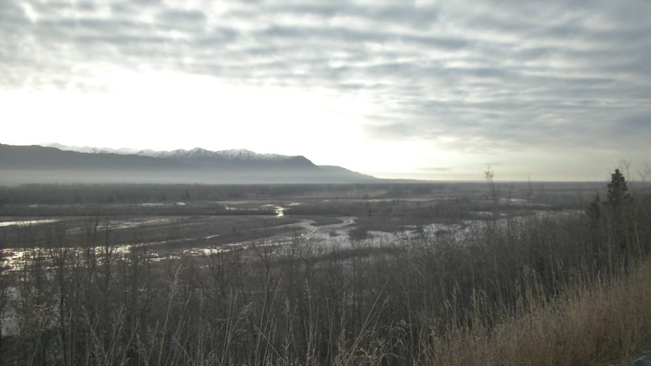
The Palmer Hay Flats State Game Refuge has grown by more than 200 acres.
Great Land Trust raised the money to purchase 236 acres along the Palmer Slough. The nonprofit donated the land to the Alaska Department of Fish and Game, which manages the refuge.
Joe Meehan, the lands and refuges program coordinator for Fish and Game, said the addition will be beneficial for people who use the land for hunting and fishing.
“It will avoid problems with people recreating in the refuge and trying to figure out where private land is to avoid trespass issues. And for the wildlife and the fish, it’s great to have a contiguous block of land that’s conserved for protection of habitats,” he said.
In 2005, Great Land Trust bought 160 acres that became Rabbit Slough access point. In 2014 the nonprofit purchased about 1,000 acres on the northern side where the new Wasilla Creek boardwalk trailhead is located.
Meehan said between the Settlers Bay Coastal Park, Palmer Hay Flats, Knik Islands Conservation area and Knik River Public Use Area, there are about 62 miles of the Knik River, estuary and coastal wetlands that are conserved.
“Those wetlands attract every year thousands and thousands of migrating birds that are coming through,” Meehan said. “Ducks, geese, swans, sand hill cranes, shorebirds. Especially in the spring it’s a wonderful place to go out and tromp around the hay flats.”
The refuge now includes more than 28,000 protected acres.
Copyright 2019 KTVA. All rights reserved.

