Hewitt & Whiskey Lake
Pike Suppression
AKSSF Semiannual Report
November 8, 2018

This semiannual report covers the activities performed by Cook Inlet Aquaculture Association (CIAA) and the Alaska Department of Fish and Game (ADF&G) taking place from May 1–October 31, 2018 under the AKSSF Grant 51003.

From May 7–11, CIAA staff conducted training for the summer seasonal staff and interns. The training sessions included were: chemical and physical hazard training, bear and firearms safety, field methods and procedures, and boating safety.

On Thursday, May 24, 2018 CIAA staff members Andy Wizik and Emily Heale flew to Whiskey Lake with Seasonal Assistant Luke Porter and Student Conservation Association Intern Collin Siberz to set up a field camp on Bourbon Mist Island that will house the northern pike (Esox lucius) suppression crew for the three years of this project. The crew built a tent platform, set up a weather port, kitchen shack, and an outhouse (Figure 1). Once the latrine was dug and the bear fencing secured around the weather port and kitchen shack the crew began training on pike suppression methods.

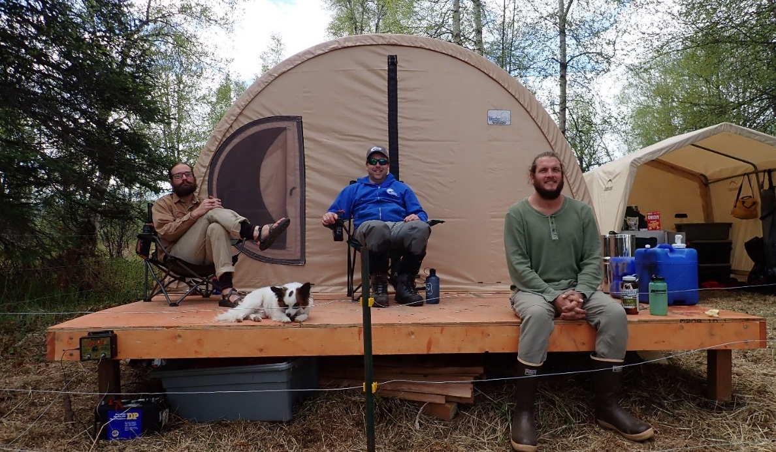
Figure 1: Seasonal Assistant Luke Porter, Biologist Andy Wizik, and Student Conservation Association Intern Collin Siberz (from left to right) sit on the porch of the weather port platform on Bourbon Mist Island, 2018.
The crew began training by setting a couple of nets on Whiskey Lake and going over the documentation of the netting location coordinates and data recording that will be used to calculate the catch per unit effort. The nets were left to soak. The crew moved on to Hewitt Lake to introduce Luke and Collin to some local residents, orient them to the lake, and set up the boat that they would be using on this lake. The following morning the crew pulled the nets on Whiskey Lake and completed training by learning the pike work-up methods and data recording steps (Figure 2).
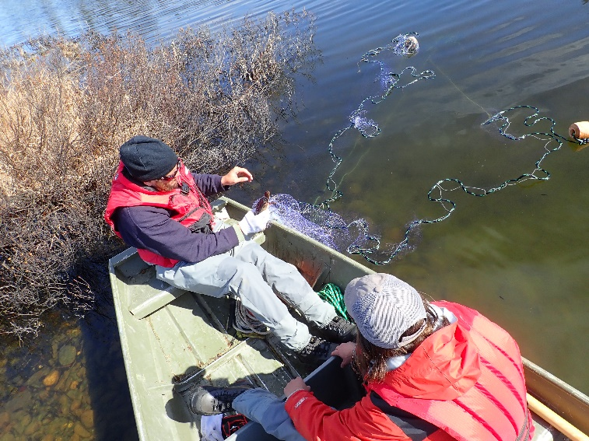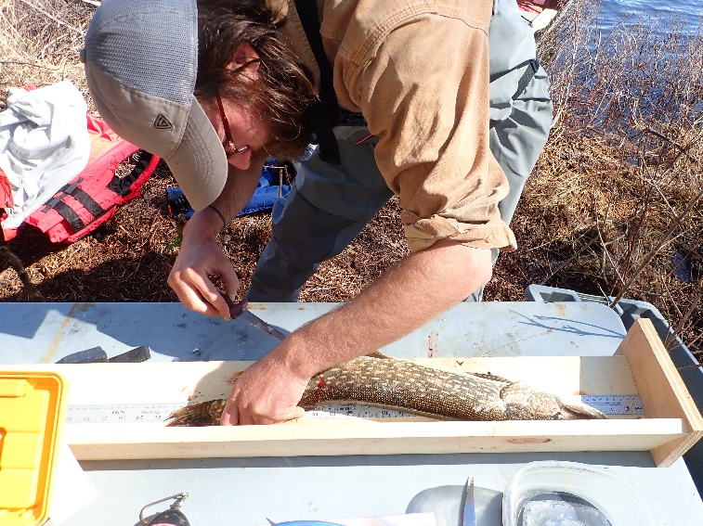
Figure 2: (Left) Luke Porter and Collin Siberz check the first nets set on Whiskey Lake, 2018. (Right) Luke Porter collects data on a northern pike caught in Whiskey Lake, 2018.

Andy and Emily left Luke and Collin at Whiskey Lake on the afternoon of Friday, May 25. From then until July 1, (when they took a break) the pair logged 976.24 gillnet/hours on Hewitt Lake and 2,377.93 gillnet/hours on Whiskey Lake. The number of pike caught on Whiskey and Hewitt lakes during this period was 1,170 and 499 respectively.

During the crew break (from July 2–10) Andy coordinated the delivery of a different 18’ jon boat to Hewitt Lake. The boat the crew had been using had been reclaimed from the woods near the portage trail between the two lakes and it was in poor condition. Adam Gabryszak, the owner of Yentna Freighting Service was hired to haul the replacement boat to Hewitt Lake, which was ready for the crew when they returned from their break.

From July 11–August 21, the crew continued gillnetting for pike logging 1,793.81 gillnet/hours in Hewitt Lake and 3,325.89 gillnet/hours in Whiskey Lake. Despite increasing their efforts on both lakes, catches at Hewitt and Whiskey lakes were lower than during the first half of the summer at 356 and 347 northern pike respectively.

Camp was closed down for the season and all gear was stowed securely by August 24 and the crew returned to Kenai on August 25, where they worked to clean up their field gear and turn in their data to Andy for review before departing for the season.

From August until the time of this report, Andy has been working on data entry and analysis. Though a comprehensive report will not be made until the project has been completed, trends in the data are being analyzed in order to maximize the suppression of northern pike during the final two years of the project. Despite increasing effort on both lakes (Figure 3), catch per unit effort (CPUE) dropped as the summer went along (Figure 4). This was not unexpected because it follows trends we have seen on many pike netting projects, but the crew for next year will be directed to maximize their net/hours during these times of high CPUE in early summer so the maximum number of pike can be removed for the effort. This decreasing CPUE can be visualized by viewing the decreasing line slopes in Figure 5 as pike become less active in the late summer.

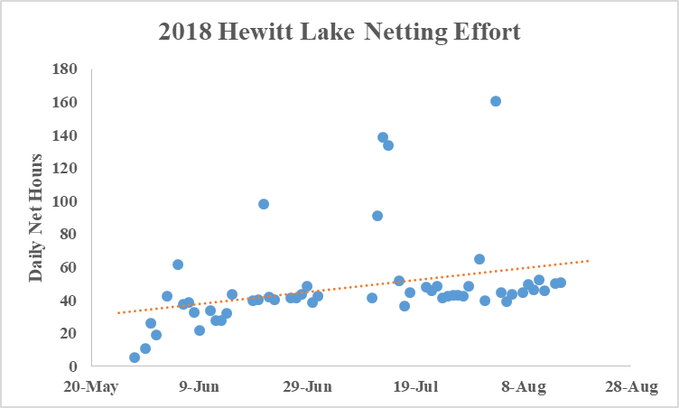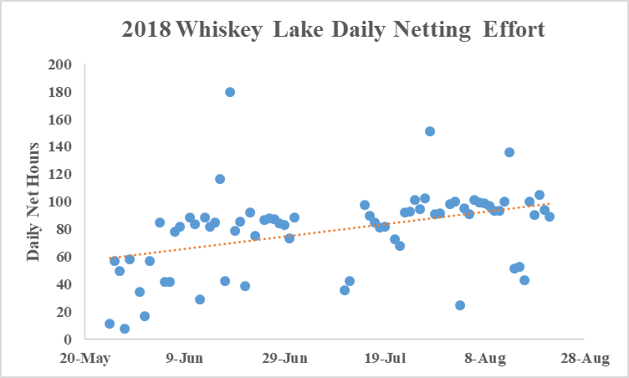
Figure 3: Gillnetting effort on Hewitt and Whiskey lakes, 2018.

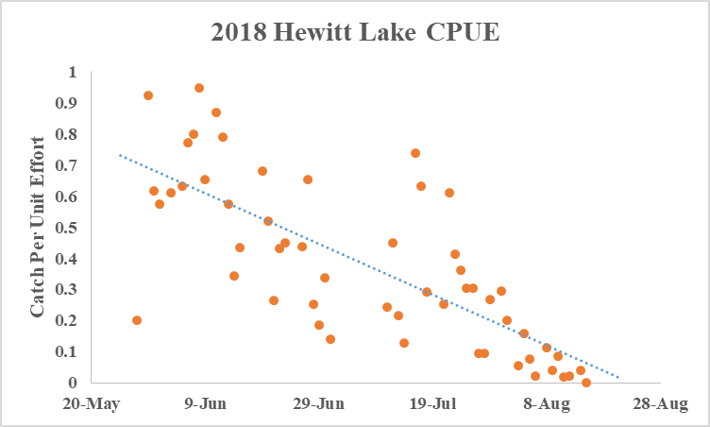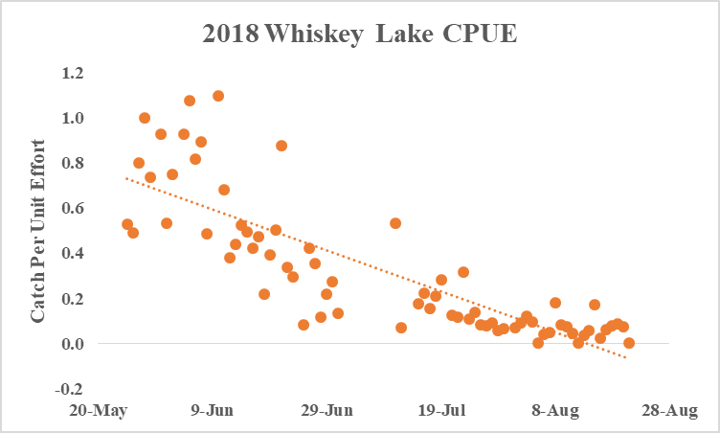
Figure 4: Catch per unit effort (CPUE) on Hewitt and Whiskey lakes, 2018.

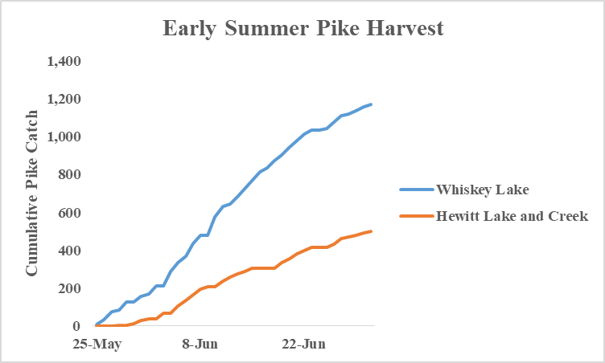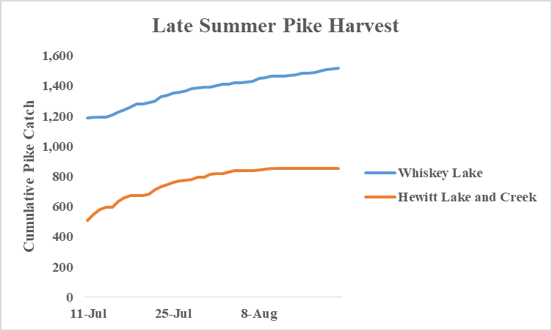
Figure 5: Cumulative early and late season northern pike harvests at Whiskey and Hewitt lakes, 2018.

Other analyses that are underway include an evaluation of the characteristics of the pike population of both lakes and the analysis of the age of pike cleithrum samples currently being read by CIAA Seasonal technician Jared Grangroth. Though the aging of the pike is currently underway and we have more analyses to complete regarding the diets of these pike, preliminary findings are as follows:

Of the 2,372 pike harvested from Whiskey and Hewitt lakes in 2018, 27 had been partially eaten by birds or otters so no stomach contents were available for analysis. An additional 544 pike had no prey items in their stomachs so the diet analysis is being conducted on the 1,801 northern pike stomachs that had contents. From those contents, individual prey items were sorted into the categories of: leeches, insects (no effort was made to identify insects to species), salmonids, burbot (Lota lota), stickleback (Gasterosteidea spp.), sculpin (Cottidea spp.), northern pike, birds, frogs, and mammals, and weighed to the nearest tenth of a gram. The dominant prey species by both mass and frequency was sticklebacks comprising 56.0% of the wet mass of all samples. This was followed by insects (16.7%), salmon (9.5%), northern pike (4.8%), and leeches (4.5%). An additional 6.6% of stomach contents were unidentifiable due to advanced digestion. Burbot, sculpin, birds, frogs, and mammals were represented in the samples with each comprising 0.2–0.7% of the total wet mass of diet items.

The average length and weight of pike captured on Hewitt Lake in 2018 was 474 mm and 0.99 kg respectively. The average length and weight of the Whiskey Lake pike was 432 mm and 0.66 kg respectively. The percentages of the pike populations that were male in Whiskey and Hewitt lakes were 54% and 56% respectively.

All quarterly invoices for this reporting period have been turned in to AKSSF. Data analysis and the aging of northern pike cleithra is continuing at this time and any further findings will be included in the April 2019 semiannual report.

On Monday September 10, CIAA Project Technician Ronnie Minter, ADFG fish and wildlife technicians Cody Volk and Caleb Owen flew to Hewitt Lake with fishery biologist, Bob DeCino, to estimate juvenile fish populations by conducting a hydroacoustic survey and apportioning population fish targets from midwater trawl net catches.

Methods and means of collecting acoustic data in Hewitt Lake were to data collection similar to DeCino and Willette (2014) and other historic sampling occasions (King and Walker 1997). A total of 14 transects were sampled in Hewitt Lake on the night of September 10, 2018 (Figure 6). Acoustic data were collected at -65dB threshold (DeCino and Willette 2014). The average Hewitt lake target strength (TS) was recorded at -54.6 dB and was similar to historical data collections (DeCino and Willette 2014, Glick and Willette 2014). The average sigma (σ) was 5.21 x 10⁻⁶ was also similar to σ’s collected in previous acoustic surveys in Susitna drainage lakes (DeCino and Willette 2014, Glick and Willett 2014).
Figure 6: Hydroacoustic transects run in September 10, 2018 juvenile population survey on Hewitt Lake.

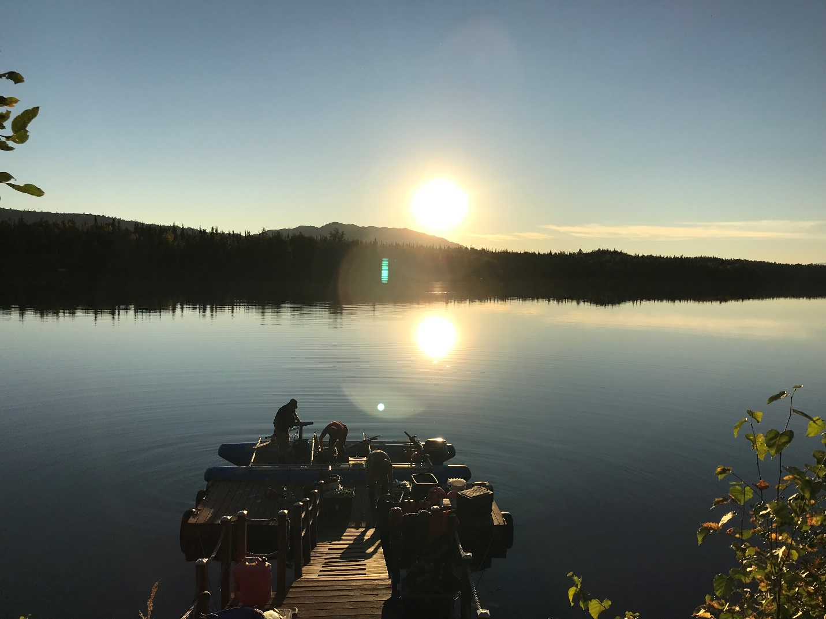
Figure 7: Installation of hydroacoustic gear on pontoon boat on Hewitt Lake September 10, 2018.

After the acoustic survey was complete the hydroacoustic gear was removed from the pontoon boat and replaced with a midwater trawl. A total of 6 tows were attempted and 4 were completed. On 2 tows the net tangled and did not open to fish and were removed from the dataset. Of the 4 tows completed a total of 1163 fish were captured. Threespine stickleback, Gasterosteus aculeatus, comprised 95.0% of the catch, followed by sockeye salmon, Oncorhynchus nerka, at 5.0%. The average length and weight for the threespine stickleback was 34.6 mm (SE=0.32) and 0.36 g (SE=0.01). The mean length and weight for age-0 sockeye salmon was 37.9 mm (SE=0.78) and 0.67 g (SE=0.05). The mean length and weight for age-1 juvenile sockeye salmon was 61.1 mm (SE=1.35) and 2.84 g (SE=0.15).

The total juvenile fish population estimate was 7,302,499 fish with a SE of 1,467,154. Threespine stickleback accounted for 95% of the total or 6,934,847 fish. Juvenile sockeye salmon accounted for 5% of the total or 367,652 fish. The total fish population estimate for Hewitt Lake was approximately 2.4 million fish less than the lowest estimate reported (2007) in DeCino and Willette (2014). However, the proportions of stickleback to sockeye salmon juveniles from midwater trawls were similar to their 2005 estimate (DeCino and Willette 2014).
References Cited

DeCino, R.D. and T.M. Willette. 2014. Susitna drainage lakes pelagic fish estimates, using split beam hydroacoustic and midwater trawl sampling techniques 2005-2008. Alaska Department of Fish and Game Fishery Data Series, No. 14-47, Anchorage.

Glick, W.J. and T.M Willette. 2014. Juvenile sockeye salmon population estimates using split-beam hydroacoustics in Susitna drainage lakes, Alaska, 2009 to 2012. Alaska Department of Fish and Game, Fishery Data Series, No. 14-48, Anchorage.

King, B.E., and S.C. Walker. 1997. Susitna River sockeye salmon fry studies, 1994 and 1995. Alaska Department of Fish and Game, Division of Commercial Fisheries, Regional Information Report 2A97-26.

