ACCESSION NO: 2024-0026

ALASKA DEPARTMENT OF FISH AND GAME
Division of Commercial Fisheries - FISH PATHOLOGY SECTION
333 RASPBERRY ROAD, ANCHORAGE, AK 99518-1599 - Phone (907) 267-2244/Fax 267-2194

REPORT OF LABORATORY EXAMINATION

LOT (YEAR, STOCK, SPECIES): Yukon River Chinook salmon, Oncorhynchus tshawytscha

FACILITY: Whitehorse Hatchery

CONTACT PERSON/ADDRESS: Warren Kapaniuk, Ensero Solutions, #3 – 151 Industrial Rd., Whitehorse, YT Y1A 2V3

SAMPLE DATE: 9/3-9/13/2023 DATE SAMPLE RECEIVED: 9/27/2023

SPECIMEN TYPE: Hearts LIFE STAGE: Adult WILD: Mix

NUMBER OF SAMPLES: 32

STATE: Paired tissues of heart fixed in 10% neutral buffered formalin and DNA stabilization buffer

HISTORY/SIGNS: These were broodfish from the Whitehorse Hatchery in Yukon Territory, Canada, that were sampled for Ichthyophonus testing as part of a large, multi-year, multi-agency research project to assess the impacts of Ichthyophonus on Yukon River Chinook salmon (Ferguson et al., 2022). This is a collaborative study with USFWS that was developed in response to concerns raised by local Yukon River fishers who have observed a recent rise in Ichthyophonus infections concurrent with small run sizes and unprecedented harvest restrictions. There has also been a large Difference Between Estimates (~40-50%) of fish abundance between the sonar project near the mouth of the river versus at the border that may indicate en route mortality. The overall goal of our work is to develop an annual monitoring program to evaluate the prevalence and density of Ichthyophonus in these fish and develop a predictive model to estimate annual Ichthyophonus-associated mortality. This planned work is developmental and will collect baseline samples needed to evaluate the feasibility of this goal. The sample location for this program would be at the Pilot Station test fishery because it is low enough in the basin to provide information for in season management. Samples from fish that have died from handling mortalities could also be used from this location to minimize the impact of lethal sampling.

The submitted samples in the present case are from broodfish collected at the Whitehorse Hatchery. They represent an important sample involving fish that successfully survived the migration to spawn and thus are of interest to compare Ichthyophonus infection prevalence and density to Chinook sampled lower in the river that have displayed clinical signs of ichthyophoniasis and high infection prevalences and densities to assess parasite-associated mortality.

Details on the sampled fish from the field crew at the Whitehorse Hatchery are provided below in Table 1 that also includes the paired results for Ichthyophonus testing for individual fish. There were 5 fish that died in holding at the Whitehorse Hatchery prior to spawning. However, two of these fish (M1 and M15) were not sampled for Ichthyophonus testing. In the future, it would be worthwhile to sample heart tissues from these fish to determine if they had clinical ichthyophoniasis that may have been associated with the pre-spawning mortality. There were also two female fish (F1-2 & F1-6) that had only partial spawning success where one skein was bloody and the eggs were still completely attached, but the other one had successfully released completely (Fig. 1).

REASON FOR SUBMISSION: Ichthyophonus research

FINAL REPORT DATE: 9/6/2024

CLINICAL FINDINGS
The following terms used in this report are defined in accordance with Bush et al., 1997.
- Prevalence: Prevalence is the number of hosts infected with one or more parasites of a particular species divided by the number of hosts examined. It is commonly expressed as a percentage when used descriptively and as a proportion when incorporated into mathematical models.
- Density: Density is the number of individuals of a particular parasite species in a measured sampling unit taken from a host or habitat, e.g., in units of area, volume, or weight. When using mean or median density, this would exclude uninfected hosts within the sampled population (i.e., analogous to intensity, but derived from a sub-sample of host tissue). This is the main metric used in this study because enumerating all parasites from the entire fish is not practical.
The Variance to Mean Ratio (VMR) is a normalized measure of the dispersion of a probability distribution, i.e., quantifies if observed occurrences are clustered or dispersed compared to a standard statistical model. This metric has the following interpretation:

VMR = 0 (not dispersed)
0 < VMR < 1 (under-dispersed)
VMR = 1 (random)
VMR > 1 (over-dispersed)

This is commonly used to define the degree of parasite dispersion among hosts (e.g., Anderson and Gordon, 1982; Rousset et al., 1996). It is calculated by dividing the sample variance by the sample mean of abundance. Temporal declines in this ratio within a sampled host population have been used as a qualitative indicator of Parasite-Associated-Mortality (e.g., Godon & Rau, 1982; Kalbe et al., 2002).

FIELD DATA: Details on the sampled fish were provided by Whitehorse Hatchery staff. 43.8% of the sampled fish were females and 25% were hatchery fish with an additional one that had a partial fin clip (Table 1).

Gross Pathology:

12/32 (37.5%) hearts with grossly visible white foci noted by hatchery staff (Table 1).

2/14 (14.3%) female fish (F1-2 & F1-6) with one bloody skein that retained eggs representing partial spawning success (Table 1).

3/32 (9.4%) pre-spawning mortality (two males and one female) plus two additional fish that were not sampled (both males: M1 & M15) (Table 1).
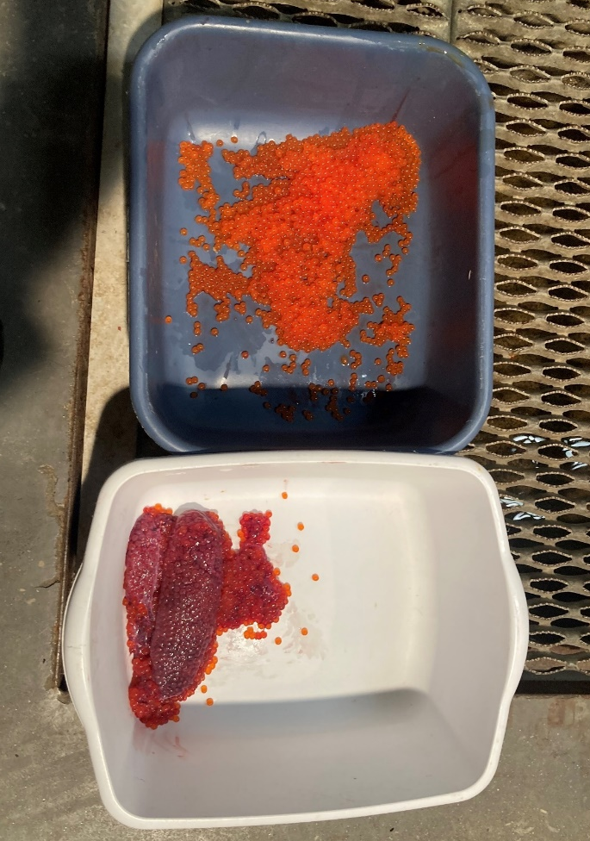
Figure 1. Gross pathology of female fish that had partial spawning success where one of the two skeins was bloody, and the eggs were still completely attached. This occurred in two female fish (F1-2 & F1-6). Photograph provided by Whitehorse Hatchery staff.

qPCR:

Extraction and assay details: Approximately 500mg of heart tissue was homogenized in buffer by bead-beating. A subsample was then taken containing roughly 20mg of homogenized tissue and DNA was then extracted following the Simplified Workflow for the MagMAX CORE Nucleic Acid Purification Kit on a KingFisher Flex purification system. A synthetically produced gene fragment, gBlock (Integrated DNA Technologies), was used for the standard curve. The Limit of Quantification (LOQ) for this assay was 10 gene copies per reaction, corresponding to a C_{T} value of 32.3. This qPCR targets the multicopy 18S rDNA gene and was performed according to the validated qPCR assay by White et al. (2013).

Density data from infected fish were normally distributed (p=0.05, Kolmogorov-Smirnov Test), which is unusual for parasite distributions within host populations (see comments below). However, all downriver samples have yielded skewed distributions, as would be expected, so median density is presented and compared to the downriver samples for consistency.

15/32 (47.0%) hearts with quantifiable Ichthyophonus DNA at or above the LOQ.

The median density of infection was 8.1 x 10⁵ copies/mg. See Table 1 below for results on individual fish.

The VMR using qPCR was 3.8x10⁶, indicating that parasites were highly aggregated within the fish host population (i.e., a VMR > 1). This means that there were fewer fish carrying most of the parasites compared to most of the fish that were either uninfected or lightly infected. However, this VMR value was a magnitude (76%) lower than that obtained from Pilot Station samples, indicating parasite-associated mortality of heavily infected fish between the two sample locations.

The infection metrics derived from qPCR for samples collected down river and across years are presented in Appendix A below for comparison.

HISTOPATHOLOGY: 5µ sections of heart tissue, Hematoxylin and Eosin (H&E) stains and/or Periodic Acid-Shift (PAS) stain; serial sections with approximately 100µm spacing; 5 sections/sample for PAS and a single section for H&E. Histology was performed on all samples.

Density data from infected fish were normally distributed (p=0.43, Kolmogorov-Smirnov Test), which is unusual for parasite distributions within host populations (see comments below). However, all down river samples have yielded skewed distributions, as would be expected, so median density is presented and compared to the downriver samples for consistency.

13/32 (40.6%) with Ichthyophonus schizonts by histology

The median density of infection was 10.4 schizonts/mm³. See Table 1 below for results on individual fish

The VMR using histology was 27.1, indicating that parasites were highly aggregated within the fish host population (i.e., a VMR > 1). This means that there were fewer fish carrying most of the parasites compared to most of the fish that were either uninfected or lightly infected. However, this VMR value was a staggering 90% lower than that obtained from Pilot Station samples, indicating parasite-associated mortality of heavily infected fish between the two sample locations.
The infection metrics derived for histology from samples collected down river and across years are presented in Appendix A below for comparison.

The grading key for assigning a histopathology index can be visualized in Acc. No. 23-0001, which is as follows:

0= no inflammation
1= mild inflammation with thin rim of fibrous connective tissue for most infections
2= discrete and well-organized granuloma formation for most infections
3= prominent and coalescing to obliterative granulomatous inflammation regardless of frequency

Overall, Ichthyophonus infections were associated with mild, focal, myositis and fibrosis to discrete granuloma formation. 84.6% of the infected fish were assigned a histopathology score of 2 and 15.4 % were rated to have a 1 severity. None of the infected fish displayed the highest severity rating of histopathology involving prominent and coalescing to obliterative granulomatous inflammation.

Comparison of qPCR to histology:

Prevalence: Prevalence by qPCR was 27.0% compared to 40.6% as determined by histology, which was not statistically different (p = 0.80; Fisher Exact test).

Density: Comparing infection density of qPCR (copies/mg) and histology (parasites/mm³) indicated a linear relationship with this dataset. qPCR was chosen to be the explanatory (independent) variable where gene copy number/mg was tested to correlate to histology as the response (dependent) variable of parasite numbers/mm³. The assumption of normality of the dependent variable with respect to the independent variable was assessed by inspection of the residual vs fitted plot. The purpose of this comparison is to provide an estimate (or range of estimates) of how many parasites in histologic section are correlated with a given qPCR copy number value because the latter is an abstract metric of infection. This would allow for a more straightforward comparison to historical studies that used histology as the gold standard and would facilitate a better understanding when communicating to other fish health experts and researchers. qPCR results were a significant predictor of histology results (p < 0.0001; linear regression) with an excellent linear fit having an adjusted R² value of 0.85 (Fig. 2). The prediction intervals are provided in the figure to describe the range of infections in histology associated with a given qPCR value.

Predictions were as follows:

10⁵ copies/mg = 1.0 schizonts/mm3 (-2.3 to 4.1 schizonts/mm³)
10⁶ copies/mg = 6.7 schizonts/mm3 (-0.4 to 13.9 schizonts/mm³)
10⁷ copies/mg = 60.0 schizonts/mm3 (46.7 to 73.4 schizonts/mm³)

Using the point estimates from each prediction point and averaging them, this would equate to approximately 138,407.5 copies/schizont. This was consistent with the estimated average copy number per schizont from the raw data that indicated the parasite had 138,407.5 copies/schizont in this dataset by simply dividing the total copies/mg by the total schizonts/mm³ for each sample with data from both tests. The parasite increases in size with time through nuclear divisions so the number of copies per schizont will vary within a range of values based on the variability of parasite size.

An additional value of performing the linear regression analyses is that it has provided a means to explore categorizing infection levels as low, medium, or high. In general, samples with qPCR results of ≤1.0x10⁵ copies/mg have correlated with single-digit counts of schizonts/mm³ in histology, those with >1.0x10⁵ copies/mg, but <1.0x10⁷ have corresponded to mostly double-digit counts of schizonts/mm3 in histology, and those with ≥ 1.0x10⁷ copies/mg represent mostly triple-digit counts of schizonts/mm³ in histology. Given the tight correlation between the two tests and the consistent finding of a similar categorization scheme from multiple datasets, the current criteria to categorize infections is as follows:

- Low = qPCR results of ≤ 1.0x10⁵ copies/mg or histology results of ≤10 schizonts/mm³

- Medium = qPCR results of >1.0x10⁵ copies/mg, but <1.0x10⁷ or histology results of >10 schizonts/mm³, but <100 schizonts/mm³

- High = qPCR results of ≥ 1.0x10⁷ copies/mg or histology results of ≥100 schizonts/mm³

Categorizing infection levels is currently exploratory and may change prior to final reporting.

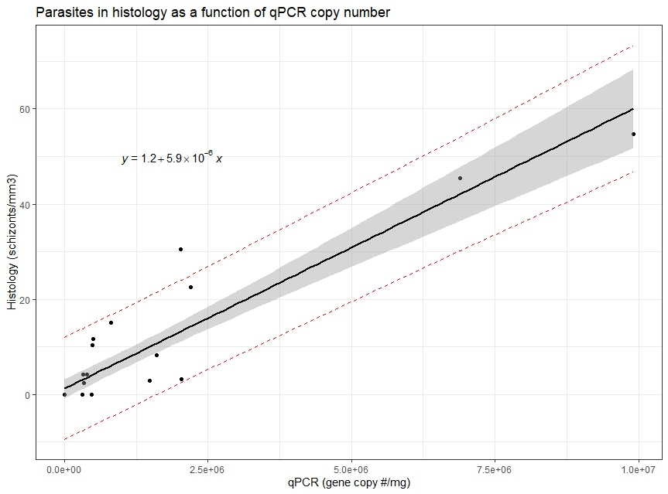
Figure 2. Linear regression of parasites in histology as a function of parasite 18S SSU gene copy number/mg by qPCR for Whitehorse broodstock 2023 samples. Shaded bar = confidence band of the linear regression, red lines = prediction intervals.

DIAGNOSIS: Ichthyophoniasis

COMMENTS/RECOMMENDATIONS: Approximately 38% of the broodstock had grossly visible lesions consistent with clinical disease by Ichthyophonus. Additionally, about 14% of the females had reduced spawning success where eggs were retained and almost 15% of the broodstock (5 of 34) died prior to spawning. Heavy Ichthyophonus infections are likely very energetically taxing to the fish, so the reduced spawning success could be attributed to infections by this parasite as both females had fairly high infections relative to those that spawned successfully (Table 1). However, another possible contributing factor might be genetics as there is natural variation in spawning success where some female fish do not ripen normally producing infertile or undeveloped eggs. Vascular anomalies could also cause partial ripening of skeins which may also account for the bloody skein description, especially when occurring in lightly or uninfected fish. All three of the pre-spawning mortality fish were test-negative for Ichthyophonus indicating that they died from other causes. There were two other pre-spawning mortality fish, but these were not sampled for parasite testing.

Based on qPCR, infection prevalence this year was estimated to be about 47% with a median infection density of 8.1x10⁵ gene copies/mg. This was slightly higher than that detected in this population of fish when sampled at Pilot Station (6.0x10⁵ gene copies/mg; Appendix A) and Rampart Rapids (5.3x10⁵ gene copies/mg; Appendix A), but similar to that of Ft. Yukon samples (8.4x10⁵ gene copies/mg; Appendix A). This shows a general trend of increased gene copy number within the infected fish population, which would be explained by the increase in nuclei that the parasite produces with time as the fish migrates upriver. However, the VMR of infections in the Whitehorse broodstock was magnitudes (76%) lower than that when fish were tested at Pilot Station, indicating parasite-associated mortality of heavily infected fish between the two sample locations. Indeed, the parasite was normally distributed within the host population in the Whitehorse broodstocks instead of the typical highly aggregated distribution that occurs in most host-parasite systems with macro-parasite attributes (Anderson and Gordon, 1982; Rousset et al., 1996). This means that the tail from the previously highly aggregated distribution (i.e., the heavily infected fish) in fish at downriver sites was absent, thus resulting in a normal distribution of parasites within the population that migrated to the Whitehorse Hatchery. The most parsimonious explanation for this phenomenon is that the most heavily infected fish died prior to reaching the upriver location.

Infection prevalence by histology was similar to that by qPCR at about 41%. The median density of infection by histology was 10.4 schizonts/mm³. This was slightly higher than that detected in this fish population at Pilot Station (8.7 schizonts/mm³; Appendix A). Histology results from Rampart Rapids and Ft. Yukon are pending. The VMR was a staggering 90% lower than that obtained from Pilot Station samples, again indicating parasite-associated mortality of heavily infected fish between the two sample locations. Furthermore, the histopathology revealed that disease was much more severe at Pilot Station where 27% of the infected fish had the most severe histopathology score compared to none detected in the Whitehorse Hatchery broodstock. This corroborates the conclusion that the most heavily infected fish died prior to reaching the upriver location of Whitehorse Hatchery where infected fish were not as diseased.

FISH HEALTH INVESTIGATOR: J. Ferguson
TECHNICAL ASSISTANCE: D. Stewart, F. Woitel

COPIES TO: FY24, Yukon Ich, Barrett (Ensero), Walter (USFWS), Herron (USFWS), Ross (DFO),
Zuray (Rapids Research Center), Kocan (Univ. WA), Hershberger (USGS), Clinton
(SSSC), Howard, Linderman, Liller, Hamazaki, Lee, Pfisterer, Wiglesworth, Lozori,
Morrill, Jallen, Gleason, Decker, Brazil, Borba, Davis, ARLIS, R. Morris, Wilson,
Vercessi, Pryor, Meyers

LITERATURE CITED:

Anderson, R., & Gordon, D. (1982). Processes influencing the distribution of parasite numbers within host populations with special emphasis on parasite-induced host mortalities. Parasitology, 85(2), 373-398. doi:10.1017/S0031182000055347

Bettge, K., Segner, H., Burki, R., Schmidt-Posthaus, H., & Wahli, T. (2009). Proliferative kidney disease (PKD) of rainbow trout: Temperature- and time-related changes of Tetracapsuloides bryosalmonae DNA in the kidney. Parasitology, 136(6), 615-625. doi:10.1017/S0031182009005800

Ferguson, J., F. West, and Z. W. Liller. 2022. Evaluating parasite associated mortality of Yukon Canadian-origin Chinook salmon. Alaska Department of Fish and Game, Division of Commercial Fisheries, Regional Operational Plan No. ROP.CF.3A.2022.03, Anchorage.

Kalbe, M. K. M. Wegner, and T. B. H. Reusch. 2002. Dispersion patterns of parasites in 0+ year three-spined sticklebacks: a cross population comparison. J. Fish Biol 60: 1529–1542.

Rousset, F., Thomas, F., De Meeûs, T., & Renaud, F. (1996). Inference of Parasite-Induced Host Mortality from Distributions of Parasit Loads. Ecology, 77(7), 2203–2211. https://doi.org/10.2307/2265713

White, V.C., Morado, J.F., Crosson, L.M., Vadopalas, B., Friedman, C.S. (2013) Development
and validation of a quantitative PCR assay for Ichthyophonus spp. Dis. Aquat. Organ. 104,
69-81.

Table 1. Field data on Yukon Chinook salmon sampled at the Whitehorse Hatchery at spawning and Ichthyophonus (Ich) test results. M = Male, F = Female. There were an additional 2 of fish (M1 & M15) that died prior to spawning but were not sampled for Ichthyophonus testing.
ADF&G Sample # | Whitehorse Sample # | Sex (M/F) | Hatchery clip | Gross heart lesions | Ich density by qPCR (copies/mg) | Ich density by histology (schizonts/mg) | Comments
1 | F1-2 | F | No | No | 1.6 x 10⁶ | 8.2 | Partial spawn
2 | F1-3 | F | No | No | 0 | 0
3 | F1-4 | F | No | Small white spots | 1.5 x 10⁶ | 2.9
4 | F1-5 | F | No | No | 0 | 0
5 | M5 | M | Yes | Few white spots | 3.9 x 10⁵ | 4.2
6 | M2 | M | No | Small white spots | 3.2 x 10⁵ | 4.2
7 | M3 | M | Yes | No | 0 | 0
8 | M4 | M | No | No | 8.1 x 10⁵ | 15.0
9 | M6 | M | No | No | 0 | 0 | Pre-spawning mortality
10 | M7 | M | No | No | 0 | 0 | Pre-spawning mortality
11 | F1-8 | F | Partial | No | 0 | 0 | Pre-spawning mortality
12 | F1-6 | F | No | Small white spots | 9.9 x 10⁶ | 54.8 | Partial spawn
13 | F1-7 | F | No | No | 0 | 0
14 | M8 | M | Yes | Small white spots | 3.2 x 10⁵ | 0
15 | M9 | M | Yes | No | 0 | 0
16 | M10 | M | No | Several small white spots | 2.0 x 10⁶ | 3.1
17 | F2-5 | F | No | No | 0 | 0
18 | F2-2 | F | No | No | 0 | 0
19 | F2-3 | F | Yes | No | 0 | 0
20 | F2-4 | F | No | No; firm | 0 | 0
21 | M12 | M | No | Few white spots | 2.2 x 10⁶ | 22.5
22 | M13 | M | No | No; firm | 0 | 0 | Dead for 1.75h
23 | M14 | M | No | Many white spots | 6.9 x 10⁶ | 45.5 | Photographed
24 | M11 | M | No | No; firm | 0 | 0
25 | F2-6 | F | No | Few white spots | 3.4 x 10⁵ | 2.4
26 | F2-7 | F | No | No; small & firm | 4.8 x 10⁵ | 0
27 | F2-8 | F | No | Few small spots | 2.0 x 10⁶ | 30.5
28 | M16 | M | Yes | No | 0 | 0
29 | M17 | M | Yes | No | 0 | 0
30 | M18 | M | No | Few white spots | 4.9 x 10⁵ | 10.4
31 | M19 | M | No | Few white spots | 5.0 x 10⁵ | 11.7
32 | M20 | M | Yes | No | 0 | 0

 |  |  | Gross | qPCR |  |  |  |  | Histology
Year | Site | Acc. No. | Lesions (%) | Prevalence (%) | Median density (copies/mg) | Ramp Rate (x) | Heavily infected (%) | VMR | Prevalence (%) | Median density (schizonts/mm³) | Ramp rate (x) | Grade 3 histology score (%) | Heavily infected (%) | VMR
2021* | Pilot | 21-039 | NA | 48.5 | 7.0 x10⁴ | 1.1 | 0 | 8.2x10⁵ | 43.7 | 20.5 | 5.8 | 29.9 | 28.7 | 157.1
2021* | Rapids† | 22-012 | 29.0 | 54.8 | 8.0 x10⁴ | 1.1 | 0 | 2.8x10⁶ | 45.2 | 66.2 | 5.8 | NA | 52.6 | 484.8
2022 | Pilot | 23-001 | 3.5 | 35.1 | 8.6 x10⁵ | 2.7 | 15.5 | 2.5x10⁷ | 34.7 | 15.3 | 1.6 | 27.1 | 21.4 | 604.3
2022 | Rapids | 23-004 | 35.5 | 38.0 | 2.3x10⁶ | 2.7 | 22.4 | 2.7x10⁷ | 34.0 | 25.1 | 1.6 | NA | 27.9 | 205.4
2022 | Eagle | 23-005 | 22.0 | 40.0 | 4.1x10⁵ | NA | 0 | 4.8x10⁶ | 38.0 | 13.9 | NA | 21.1 | 10.5 | 86.8
2023 | Pilot | 23-045 | 25.0 | 47.4 | 6.0 x10⁵ | 0.9 | 13.5 | 1.6x10⁷ | 43.0 | 8.7 | Pend-ing | 26.9 | 19.4 | 268.6
2023 | Rapids | 24-011 | 45.0 | 46.7 | 5.3 x10⁵ | 0.9 | 3.6 | 1.3x10⁷ | Pending | Pending | Pend-ing | NA | Pending | Pend-ing
2023 | Ft. Yukon | 24-010 | 35.6 | 35.6 | 8.4 x10⁵ | NA | 3.1 | 9.8x10⁶ | Pending | Pending | NA | NA | Pending | Pend-ing
2023 | Whitehorse | 24-026 | 37.5 | 47.0 | 8.1 x10⁵ | NA | 0 | 3.8x10⁶ | 40.6 | 10.4 | NA | 0 | 0 | 27.1
Appendix A. Summary of gross, qPCR, and histology results from tested Chinook salmon samples collected across study sites and years to date. These are provided for descriptive comparisons as final analyses are forthcoming in future study reports. VMR = variance to mean ratio. Grade 3 histology score is described above in the histology section. Ramp rate = fold change (x) in median infection density from fish sampled at Pilot Station compared to those from Rapids to estimate the amount of parasite proliferation in fish between these two localities. The category of heavily infected fish is a metric that is being developed from this research and is currently defined as samples with ≥ 1x10⁷ copies/mg by qPCR or ≥100 schizonts/mm³ by histology based on visual inspection of the data, exploratory plots, and the results from the linear regression analyses; note: this is the percentage of infected fish (i.e., uninfected fish excluded) within this category. †= Data from samples collected at Rapids in 2021 are presented using 42 paired qPCR and histology samples, but excludes the additional 20 samples that were only sampled for histology, including these samples changes the histology prevalence to 38.7% (24/62) and median intensity to 128.7; *= the extraction for qPCR testing of the samples collected in 2021 was drastically different than that used for samples collected in 2022 forward that may limit comparison of data with the pilot study performed in 2021.

