ACCESSION NO: 2024-0043

ALASKA DEPARTMENT OF FISH AND GAME
Division of Commercial Fisheries - FISH PATHOLOGY SECTION
333 RASPBERRY ROAD, ANCHORAGE, AK 99518-1599 - Phone (907) 267-2244/Fax 267-2194

REPORT OF LABORATORY EXAMINATION

LOT (YEAR, STOCK, SPECIES): Yukon River (Rampart Rapids & Ft. Yukon) Chinook salmon, Oncorhynchus tshawytscha

FACILITY: USFWS Northern Alaska Fish and Wildlife Field Office

CONTACT PERSON/ADDRESS: Keith Herron, USFWS, 101 12th Ave., Room 110 Fairbanks, AK 99701

SAMPLE DATE:7/2/2023-8/5/2023 DATE SAMPLE RECEIVED: 4/30/2024

SPECIMEN TYPE: LIFE STAGE: Adult WILD: Yes

NUMBER OF SAMPLES: 54 fish samples with 5 sections each = 270 sections

STATE: PAS-stained histological slides

HISTORY/SIGNS: Samples were sent to the Fish Pathologist to examine, count Ichthyophonus parasites, and interpret histopathology to compare to the parasite counts estimated by two different fish health specialists, one at Univ. of Washington and the other at USGS’s Western Fisheries Research Center. This was requested because parasite counts between those two investigators have had a large discrepancy, so samples were sent to the ADF&G Fish Pathology Lab as a third examiner where results from the previous two histological examinations were blinded. Results may be used to perform a linear regression to adjust counts for inter-reader variability.

REASON FOR SUBMISSION: Assess parasite counts and histopathology as a third investigator to examine inter-reader variability

FINAL REPORT DATE: 8/8/2024

CLINICAL FINDINGS
HISTOPATHOLOGY: 5µ sections, PAS-stained at USGS, Western Fisheries Research Center. Each slide represented samples from each fish with 5 sections produced for each slide. Step sections were taken 100um apart. Sections were not labeled on the slide, so the ADF&G Fish Pathologist labeled these consistently as shown in Fig. 1.

The following criteria were developed to assess these samples:

- Lesion with consistent morphology of Ichthyophonus schizont (e.g., size/shape, features void of blood vessels, etc.) with appressed myocyte or inflammatory infiltrates with or without PAS-stained plasmodial stages (Fig. 2)
- Occurs within same location as other sections

Both criteria must be met if PAS-negative, but the detection of PAS-positive plasmodial stages was regarded as a sufficient standalone criterion.

The size of the tissue sections were not measured since all previous samples from these upriver locations have used the following approach to estimate tissue size:

Parasite density was determined from the sum of parasites present in all five sections removed from the 8mm biopsy and divided by the volume of the tissue based on the geometrical equation for calculating the volume of a cylinder:

Volume of the five sections was calculated from the equation:

V = π r² h

where: V = volume of the 5 sections; π = 3.14; r = radius (4 mm); h = height (25 µm).

However, ADF&G Fish Pathology staff measured a few representative samples from this subset and from Pilot Station samples collected in 2023 and found large variability in the circumference of different sections. The circumferences were always smaller than estimated by the geometric equation by a factor of about 20-30%.

This is caused by tissue shrinkage from fixation, processing, and sectioning. The circumference of sections within a single biopsy plug can also vary due to sectioning the biopsy at slightly different depths where deeper sections tend to have more tissue than more superficial ones that commonly requires facing the block to obtain a flat section with approximately the same amount of tissue across different planes of sectioning. It is well established that formalin fixation can shrink tissues, such as parasite spores, as much as 15% (Parker and Warner, 1970; Hedrick et al., 1991). Therefore, this approach to estimating density was used, but is worth noting that it may be inaccurate and results in potentially higher variation than inter-reader variability when comparing to the histological data from Pilot Station.

54/54 test-positive for Ichthyophonus (see Tables 1 & 2 for raw data)

Rampart Rapids median density: 9.5 schizonts/mm³

Ft. Yukon median density: 10.3 schizonts/mm³

Overall, samples from Ft. Yukon appeared to have a higher severity of myocarditis and other host responses, such as necrosis. However, this was not assessed using the ADF&G’s score developed for Pilot Station samples since this has not been performed on upriver samples in the past and was not a core objective for assessing these samples. There was one sample (Rampart Rapids # 94) that had many small germinating parasites (Fig. 3). This was thought to be due to either: 1) post-mortem replication (artifact) or 2) disseminated infection. This was a unique presentation based on results from over 1,000 sections read on this project. The ADF&G Fish Pathologist reached out to USFWS to inquire about the amount of time that occurred post-mortem prior to sampling. USFWS staff indicated that samples from this fish may have been collected later than most fish post-mortem. However, the sample collection was within the general guidelines of 3-4h post-mortem. Either explanation could explain the results, but my interpretation would be that this represents post-mortem replication of the parasite (artifact) based on experience reading many sections in this system and the feature of germinating parasites. All parasites were counted in this sample despite the potential for the smaller and germinating parasites representing post-mortem replication by the parasite that would be an artifact.

DIAGNOSIS: Ichthyophoniasis, several fish with severe disease, especially those from Ft. Yukon

COMMENTS/RECOMMENDATIONS: These histological sections were examined by a third investigator, the Fish Pathologist at ADF&G’s Fish Pathology Section to assess inter-reader variability. The pathologist devised criteria for determining the presence of parasites with little features present in different sections. Developing such criteria at the beginning of a research project is imperative, especially when comparing results from other histopathologists. The lack of such criteria for all histopathologists to utilize likely explains most of the inter-reader variation. For example, some examiners may omit granulomas since schizonts were out of the plane of section despite PAS-positive plasmodia present in the lesion and occurring at the same location as in other sections with clearly identifiable schizonts. Additionally, less experienced histopathologist may even count blood vessels as schizonts that were dislodged upon sectioning due to their similar shape and size. Results were provided back to the case contact in an Excel file that was requested at the time of sample submission. Those results are also presented below in Tables 1 & 2. Besides providing parasite counts for this comparison, I also noted what appeared to be a higher infection density and disease severity in the Ft. Yukon samples compared to those collected at Rampart Rapids. There was one sample (#94 from Rampart Rapids) that appeared to have artificially inflated numbers of parasites from post-mortem replication based on experience examining many sections from fish in this system, including those with disseminated infections where germinating parasites as seen in this sample have not yet been encountered. All parasites were counted in this sample as the tissues were collected and fixed within the general guidelines of 3-4h post-mortem. Lastly, we determined that the approach to estimating tissue volume may be significantly over estimating tissue size. This may be the most important source for variability when comparing to Pilot Station histology data that measured every tissue sample with photomicroscopy software. This is because fixation and processing for histological sections results in appreciable shrinkage of tissues, as has been shown for formalin-fixed parasite spores (Parker and Warner, 1970; Hedrick et al., 1991). There are only a few approaches to address this source of variation. Every sample could be measured with photomicroscopy software, but that would be impractical. Instead, representative samples could be measured, and the average determined so that a shrinkage factor (percentage) could be applied to all samples. Alternatively, no actions could be taken except simply stating the caveat of unaccounted tissue shrinkage when estimating tissue volume with this approach.

FISH HEALTH INVESTIGATOR: J. Ferguson
TECHNICAL ASSISTANCE: None

COPIES TO: FY24, Yukon Ich, Walter (USFWS), Kocan (Univ. WA), Hershberger (USGS), Lovy
(USGS), Linderman, Liller, Hamazaki, Davis, ARLIS, R. Morris, Wilson, Vercessi, Pryor,
Meyers

LITERATURE CITED:

Hedrick, R. P., A. Wishkovsky, J. C. Modin, and R. J. Toth. 1991. Three myxosporeans found in the cranial and brachial tissues of rainbow trout in California. Journal of Aquatic Animal Health 3: 55–62.

Parker, J. D., and M. C. Warner. 1970. Effects of fixation, dehydration and staining on dimensions of myxosporidian and microsporidian spores. Journal of Wildlife Diseases 6: 448–459.

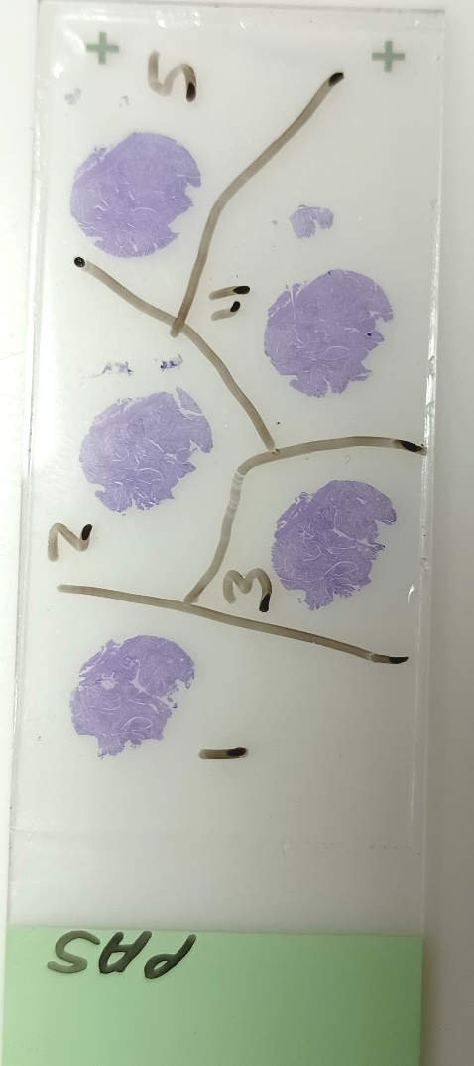
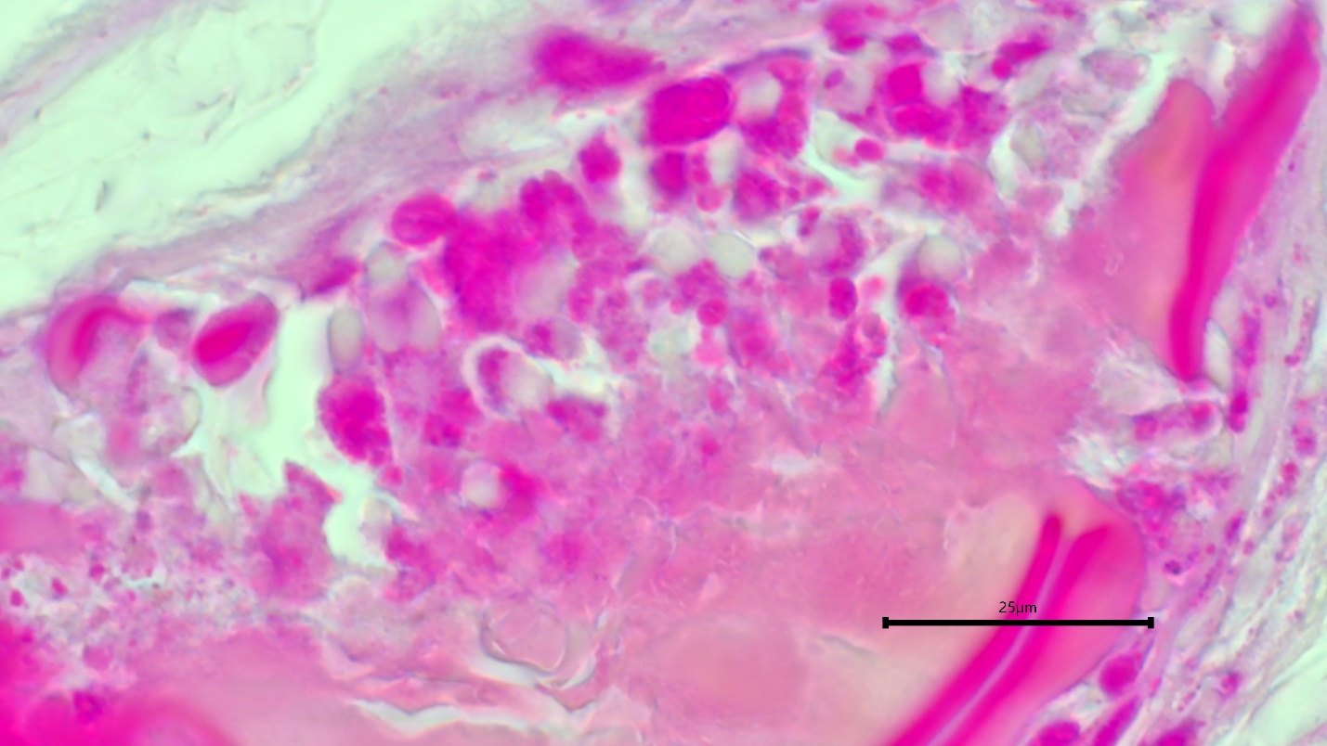
Figure 1. Example of how the 5 sections were labeled by the ADF&G Fish Pathology Section for tracking results.

Figure 2. Histopathology showing PAS-positive plasmodia of Ichthyophonus (pink spherical bodies; arrow) used as part of criteria for including counts for the parasite.

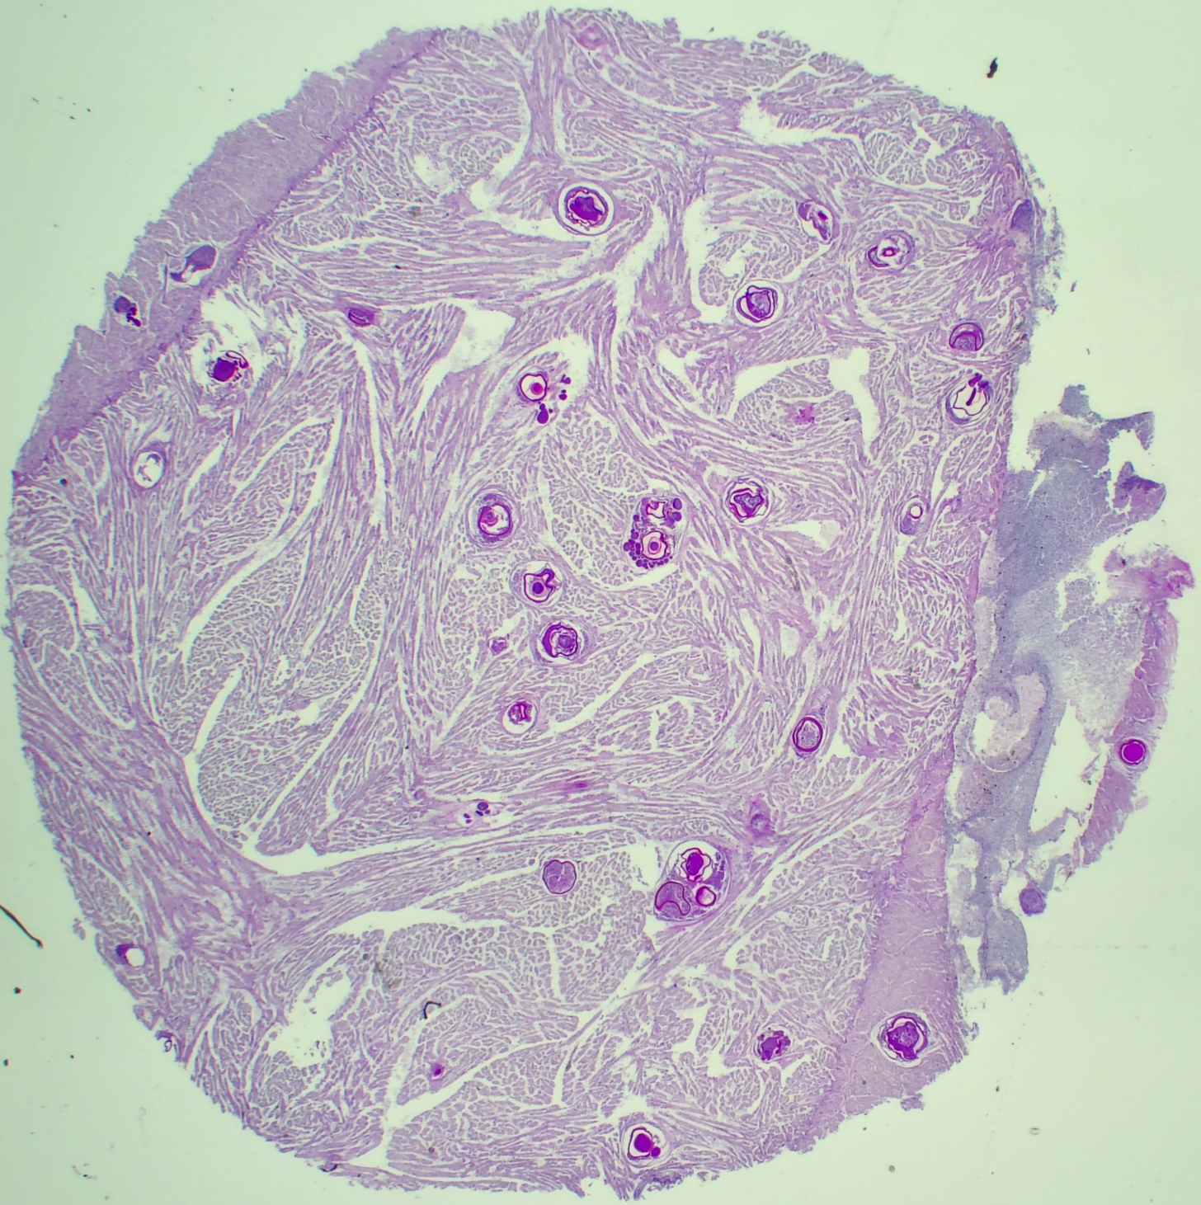
Figure 3. Histopathology of Fish #94 from Rampart Rapids with a high parasite density and schizonts with many associated small, germinating parasites (arrows) that may have either been due to post-mortem parasite replication (artifact) or a disseminated infection. My interpretation is of the former based on examining many sections of samples from this system, including fish with disseminated infections. The germinating stages are suspicious for post-mortem parasite replication. Samples from this fish were collected from a longer post-mortem period than most other fish but was within the guidelines of 3-4h post-mortem. All parasites were counted and reported for this sample.

Table 1. Summary of parasite counts and histopathology notes for Rampart Rapid samples.
Sample # | Section 1 | Section 2 | Section 3 | Section 4 | Section 5 | Comments
1 | 0 | 1 | 0 | 1 | 1 | Section 5: 1 spherical lesion with PAS+ve plasmodial like cells
7 | 0 | 1 | 0 | 1 | 3 | Section 2: PAS+ve plasmodia-like cells + located in other sections with Ich
19 | 3 | 5 | 4 | 6 | 5 | Few sections: 1) PAS+ve material and 2) located in other sections with Ich
23 | 2 | 4 | 3 | 2 | 1 | Few sections: 1) PAS+ve material and 2) located in other sections with Ich
24 | 21 | 27 | 26 | 31 | 37 | Few sections: 1) PAS+ve, morphology (not vessels) & 2) located other sections with Ich
32 | 0 | 1 | 1 | 1 | 0
36 | 12 | 14 | 13 | 16 | 14 | Few sections: 1) PAS+ve material and 2) located in other sections with Ich
42 | 2 | 1 | 3 | 2 | 1 | Few sections: 1) PAS+ve material and 2) located in other sections with Ich
44 | 0 | 1 | 0 | 1 | 0 | Few sections: 1) PAS+ve material and 2) located in other sections with Ich
49 | 4 | 6 | 6 | 5 | 6 | Sections 3 & 4: 1) PAS+ve material and 2) located in other sections with Ich
55 | 1 | 3 | 2 | 3 | 2 | Sections 1, 2, 4, & 5: suspicious, but unconfirmed. Excluded in final count
56 | 1 | 2 | 2 | 1 | 1 | Sections 1 & 4: suspicious, but unconfirmed by devised criteria so excluded in final count
58 | 6 | 5 | 4 | 5 | 6 | Few sections: 1) PAS+ve material and 2) located in other sections with Ich
61 | 3 | 4 | 5 | 2 | 2 | Focal edema; PAS+ve precipitation (artifact) present but not counted
65 | 1 | 2 | 1 | 6 | 9
68 | 0 | 1 | 0 | 2 | 4 | Section 2: 1) PAS+ve and 2) located in other sections with Ich; PAS+ve precipitation (artifact) present but not counted
73 | 1 | 4 | 2 | 3 | 4
74 | 1 | 1 | 0 | 3 | 3 | Section 2 confirmed with section 5
78 | 2 | 8 | 4 | 9 | 6 | One schizont in section 4 confirmed with section 5
82 | 4 | 6 | 3 | 6 | 2 | Section 1 confirmed with other sections; few small parasites in section 4
94 | 71 | 47 | 53 | 65 | 35 | Many small germinating parasites due to 1) post-mortem replication (artifact) or 2) disseminated infection. Unique finding based on results from many sections read on project. USFWS indicated fish may have been sampled later than others, but within the guidelines of 3-4h post-mortem. Likely due to post-mortem replication (artifact) based on experience reading many sections in system and presence of germinating parasites. All parasites counted despite potential for post-mortem parasite replication.
95 | 1 | 0 | 2 | 1 | 1
99 | 0 | 1 | 1 | 1 | 1
104 | 8 | 8 | 5 | 11 | 11
106 | 2 | 0 | 2 | 1 | 1
122 | 5 | 7 | 6 | 5 | 5 | counts in section 1 confirmed with other sections
125 | 14 | 12 | 13 | 14 | 14
126 | 1 | 0 | 1 | 0 | 1 | Section 5 met criteria based on PAS+ve cells and same location as other sections
135 | 37 | 44 | 44 | 53 | 66
138 | 1 | 6 | 8 | 4 | 7
153 | 2 | 1 | 1 | 1 | 1
154 | 1 | 1 | 0 | 1 | 1 | count in section 4 confirmed with section 5
163 | 12 | 27 | 15 | 30 | 14
169 | 3 | 2 | 0 | 0 | 0 | Section 1: 1) PAS+ve material and 2) located in other sections with Ich
174 | 1 | 1 | 1 | 1 | 2 | Section 3: 1) PAS+ve material and 2) located in other sections with Ich; 1 focus of inflammation in section 5 unconfirmed so excluded from count

Table 2. Summary of parasite counts and histopathology notes for Fort Yukon samples.
Sample # | Section 1 | Section 2 | Section 3 | Section 4 | Section 5 | Comments
2 | 11 | 11 | 11 | 9 | 9 | large focus with ~6 Ich schizonts (high severity); section 4 = tissue dislodged
6 | 5 | 1 | 4 | 2 | 3 | Sections 1 & 4 confirmed: 1) PAS+ve material and 2) located in other sections with Ich; each had an inflammatory focus unconfirmed to be Ich and thus excluded from counts
13 | 1 | 0 | 0 | 0 | 1
21 | 5 | 4 | 3 | 4 | 5 | Sections 2, 3, & 5 confirmed: morphology, PAS, and located in other sections with Ich; Sections 2 & 5 had an inflammatory focus unconfirmed to be Ich and thus excluded from counts; slide had sections pre-numbered that differed from my section numbering
23 | 3 | 3 | 4 | 2 | 3 | Section 1 confirmed: morphology, PAS, and being in same locations as other sections
24 | 0 | 1 | 1 | 1 | 1 | Sections 2 & 3 confirmed: morphology, PAS and located in other sections with Ich
28 | 2 | 1 | 2 | 0 | 1 | Section 1 & 2 confirmed: morphology, PAS and located in other sections with Ich; one schizont in section 1 was very faintly stained
29 | 2 | 1 | 1 | 4 | 6 | Section 1, 4 & 5 confirmed: morphology, PAS and located in other sections with Ich; one schizont in section 1 was very faintly stained
33 | 4 | 3 | 5 | 2 | 2 | Sections 2 & 3 confirmed: morphology, PAS and located in other sections with Ich being (1 needed confirming in each of these 2 sections)
37 | 9 | 17 | 14 | 13 | 16 | Section 3 confirmed: morphology and located in other sections with Ich; counts in section 5 confirmed with presence of parasite in same locations in section 1
40 | 11 | 0 | 3 | 1 | 1
42 | 2 | 2 | 3 | 3 |  | Severe inflammation, esp. in section 4; poor quality slide with immiscible product
43 | 0 | 2 | 1 | 3 | 2 | Severe inflammation, prominent granulomas, highest rating on my scale (3 on 0-3 scale)
51 | 0 | 1 | 0 | 0 | 1 | immiscible product
56 | 0 | 1 | 1 | 0 | 1 | immiscible product
63 | 9 | 4 | 3 | 3 | 3 | 1 Ich-like schizont in section 1 not counted because unconfirmed due to poor quality slide that had graininess due to immiscible product and poor/light staining
66 | 1 | 1 | 1 | 0 | 0 | Severe, large inflammatory foci, unconfirmed Ich in sections 4 & 5: may be due to something else; necrosis also present; Section 3 confirmed: morphology & located in other sections with Ich
75 | 0 | 1 | 1 | 1 | 1 | Section 4 confirmed with PAS+ve cells and located in other sections with Ich
90 | 2 | 2 | 4 | 2 | 3 | section 1= poor/light staining; section 4 = 3rd focus unconfirmed to be Ich so excluded; sections 3 & 5 confirmed: morphology and located in other sections with Ich

