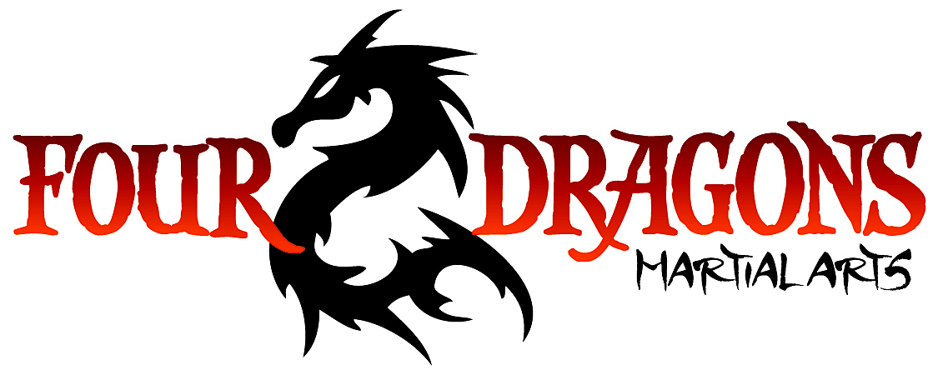

Junior Blue Stripe Belt
Position & Movement | - Hapkido Pattern #3 (basic)  - Pivot  - Ground defense position
Rolls, Falls & Throws | - Bamboo dives  - Kick out side fall  - Outside reap  - Reverse outside reap
Striking | - Kicks  - Back kick  - Oblique kick  - Axe kick  - Boxing  - Body punches  - Blocks  - Chasing parries
Joint Manipulation  (Intermediate & teen only) | - Collar  - Reverse wrist flex  - Rotational wrist lock  - Back Collar / Hair  - Chicken wing  - Wrist flex  - Arm bar

