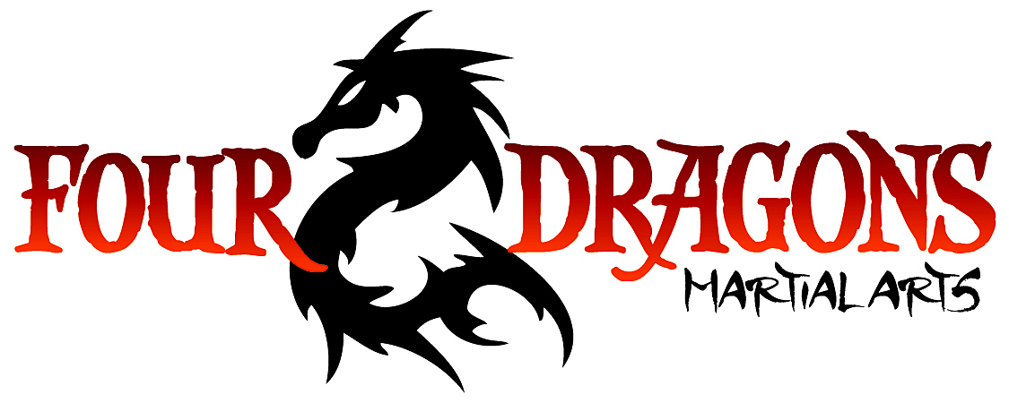

Junior Bodan Belt
Position & Movement | - Kempo 1  - Side mount  - Scarf hold
Rolls, Falls & Throws | - Obstacle dives  - Wall dives  - Moving bamboo  - Tackle throw  - Rolling kick over
Striking | - Kicks  - Jump spin OP  - Flying knee  - Spin heel  - Jump double side kick  - Boxing  - Ridge & spear hands  - Blocks  - Elliptical block
Self Defense Technique  (Intermediate & Teen only) | - Back Grabs  - Key  - Reverse Key  - Head lock / Throat grab  - Chicken wing  - Arm bar  - Wrist Flex

