Questions and Answers –
Discovery and Delivery Configuration in Primo VE

Could you have just entered the exact title?

Yes, you could have entered the exact title as a search, and based on the keywords in the title it should appear at or near the top of the results. For even more accurate results, you could put the title in quotation marks, or go to the Advanced Search, select Title for the field, and select contains/is(exact)/starts with.

We have some titles that show "Available Online" in Primo results, but that label briefly appears then disappears in the Primo record. They are set up properly in Alma, so does that sound like a glitch that we should report to Ex Libris or PASCAL? Or a setting we need to change somewhere?

Please report this and provide examples. We’d need to assess what type of record it is first (local or from CDI?) to determine if it’s an issue with the Real-time-availability function between Alma and Primo, or if it’s something to do with the interoperability between Alma/CDI and Primo.

How do you add that ILL request link within the item records?

This is done using the General Electronic Services; the ILL service would be configured in the Fulfillment Configuration > Discovery Interface Display Logic > General Electronic Services area.

I have enabled the TOC search in the Advanced Search in Primo. Yet, the TOC search is NOT searching the 505 (TOC) MARC field in the bib record in our library catalog. So, does the TOC search only search CDI records? Is there a way to search the 505 in the bibliographic record itself?

In the out-of-the-box settings, Primo uses all of the 505 subfields for display, but only indexes the content in the 505$a for search:
https://knowledge.exlibrisgroup.com/Primo/Product_Documentation/020Primo_VE/050Other_Configuration/Mapping_to_the_Display%2C_Facets%2C_and_Search_Sections_in_the_Primo_VE_Record#MARC21_and_KORMARC_-_Search_Mapping

If you would like to include the 505$t in the search, you would need to go to Discovery >Manage Display and Local Fields, then create a new local field that used all of the 505 field and subfields.

You can learn about the complete configuration by referring to the training series below (Specifically, the Bibliographic Local Field Mapping session, the Best Practices session, and the Local Fields for Consortia session to see how this would work in your particular environment.) Your configurations would apply only to the data in Alma (i.e. not CDI data)
https://knowledge.exlibrisgroup.com/Primo/Training/Primo_VE_Training/Additional_Primo_VE_Training/Primo_VE_Normalization_Suite

Also, is there a list anywhere of every MARC field that is included in various searches?

https://knowledge.exlibrisgroup.com/Primo/Product_Documentation/020Primo_VE/050Other_Configuration/Mapping_to_the_Display%2C_Facets%2C_and_Search_Sections_in_the_Primo_VE_Record#MARC21_and_KORMARC_-_Search_Mapping

When Jean searched in Primo, the dropdown menu showed the search scopes and suggested search terms. Ours only has search scopes. How do we turn on suggested search terms?

You can enable Autocomplete in the View on the General tab here:
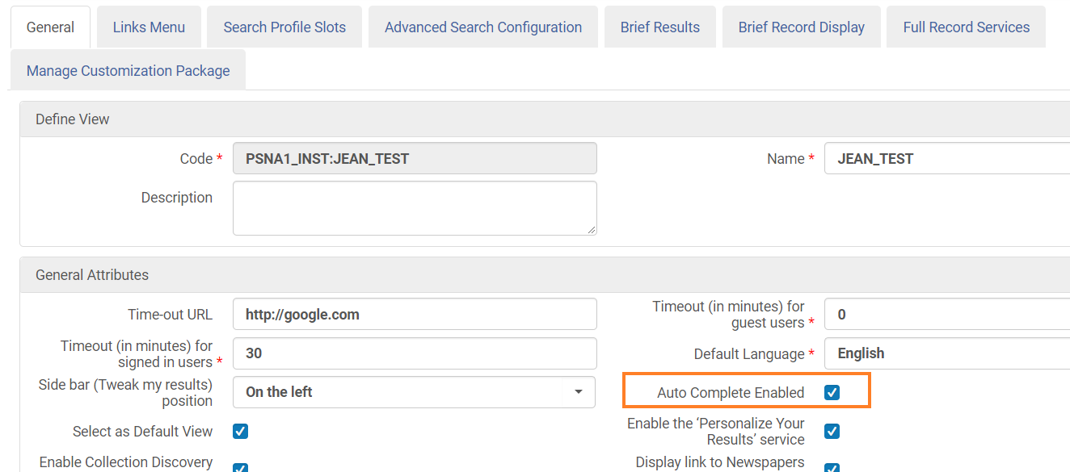

I have noticed that some folks have two links (books and articles). Is this truly necessary. I am currently using one that seems to work for both material formats.

This question referred to the ILL links configured in the General Electronic Services. In the demonstration, we had two separate links for Illiad’s ILL because the URL template is different when it’s an article or journal VS a book or chapter. If you are currently using one that works for both, that is fine – this just means that the URL template works for all of the formats.

Is there a setting that would allow $q of ISBN to be shown (like "paperback") after the ISBN proper in the Primo record?

It’s not a setting, but it’s possible to change the display by going to Discovery > Manage Display and Local Fields. You’d then Add field > Add a display field, select the field you wanted to update, then change the drools. More details instructions can be found in the documentation and training below.

https://knowledge.exlibrisgroup.com/Primo/Product_Documentation/020Primo_VE/025Display_Configuration/040Configuring_Local_Display_and_Search_Fields_for_Primo_VE

https://knowledge.exlibrisgroup.com/Primo/Training/Primo_VE_Training/Additional_Primo_VE_Training/Primo_VE_Normalization_Suite

To be clear on the normalization shown - this is a Primo normalization, not an Alma normalization? As in, this is not changing the underlying coding in the MARC21 bib record from 505$t to 505$a?

That is correct – in Discovery, you can change how the record displays, and what fields are indexed for search and facets. You’re not changing the data in the MARC record itself.

