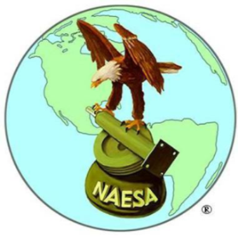  “In the Public Interest” | NAESA International  National Association of Elevator Safety Authorities | 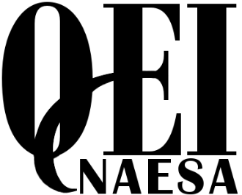
PO Box 4367
Mankato, MN 556002
Phone: 360-292-4968 Fax: 360-292-4973
Email: megan@naesai.org Web: www.naesai.org
TEXAS CODE UPDATE SEMINAR

Date: Tuesday, April 24th, 2018

Location: Fort Worth, TX

Time: 7:00am-5:30pm (10hrs)

Cost: $175 for Members - $200 for Non-Members

NAESA International’s 2018 Code Update Seminars are a fast-paced interactive program focusing on several aspects of Code, to include the ASME’s and their reliance to other referenced codes and standards. As usual the intent is to focus on code changes occurring in the newest edition, however we will dive into specific fundamentals of “how to or how does” the updates change the aspects to how inspectors and mechanics perform their job duties. Please see the items below which outline the subjects offered on this date:

- ASME A17.1 / CSA B44- 2016 Safety Code for Elevators and Escalators
- ASME A17.1 Part 8.6- Maintenance, Repair, Replacement and Testing
- NFPA 70 National Electrical Code- 2017
- FEO 2.27.3 Code Update and Training with FSAE International Building Code (IBC)
- NFPA 13 & 72- 2017 Standard for Installation of Sprinklers/ National Fire Alarm and Signaling Code
To register – please complete the form below: (Registration is also available online at www.naesai.org)
REGISTRATION FORM
April 24th, 2018 – Fort Worth, TX
NAME:
MAILING ADDRESS:
CITY/STATE/ZIP: | City | State |  |  | Zip
EMPLOYER:
CONTACT INFO: | Email |  | Cell
 | Phone |  | Fax
PAYMENT METHOD
Check One: CHECK VISA MC AMEX MO  Make check payable to NAESA International. |  | TOTAL AMOUNT:
Credit Card #: |  | Exp. Date: |  |  |  | CVV:
Name on Card: |  | Billing Zip:
I hereby certify that the above information is true, accurate, and complete.
SIGNATURE |  |  |  | DATE
Return completed form and payment to: NAESA International Executive Office, PO Box 4367, Mankato, MN 56002
Phone: 360-292-4968 Fax: 360-292-4973 Email: megan@naesai.org

NAESA International Education Program
Code Update Seminar
Fort Worth, TX
April 24th, 2018
LOCATION & TIME: | Holiday Inn DFW Airport South  14320 Centre Station Drive  Fort Worth, TX 76155  Tuesday from 7am to 5:30pm (10-hour class)
REGISTRATION FEE: | Registration fee is $175.00 for Members and $200.00 for Non-Members.  You may pay by check (U.S. currency), money order, American Express, MasterCard, or Visa. Make checks payable to NAESA International. Call 360-292-4968 to register over the phone or visit www.naesai.org to register online.
ACCOMMODATIONS: | Holiday Inn DFW Airport South  14320 Centre Station Drive  Fort Worth, TX 76155  Phone: 817-399-1800 Fax: 817-399-1801  www.hidfwairport.com  Please contact the hotel directly to make reservations. NAESA does not provide a room block discount for this class.
APPROVALS: | This seminar has been approved for 1.0 CEUs (10 hours) by NAESA. You must be present the entire time and sign the sign-in sheets to receive full credit. Contact Megan at megan@naesai.org for the most current information on outside approvals.
QUESTIONS: | Contact us by phone at 360-292-4968, by fax at 360-292-4973  or e-mail megan@naesai.org.
DUE TO LIMITED SPACE, REGISTRATION FOR ALL SEMINARS, COURSES AND WORKSHOPS ARE ON A FIRST COME, FIRST SERVE BASIS. PLEASE BE ADVISED THAT CLASSES MAY FILL TO CAPACITY PRIOR TO THE DEADLINE DATE. ALTHOUGH EVERY EFFORT WILL BE MADE TO ACCOMMODATE INDIVIDUALS WISHING TO ATTEND, NAESA RESERVES THE RIGHT TO DECLINE REGISTRATIONS IF A CLASS HAS FILLED TO CAPACITY.
CANCELLATION POLICY: THE SEMINAR/COURSE FEE OR TEST FEE, LESS A $50.00 CANCELLATION FEE, WILL BE REFUNDED IF WRITTEN NOTICE IS GIVEN TO NAESA AT LEAST TWO WEEKS PRIOR TO THE START DATE OF THE SEMINAR/COURSE OR TEST. NO REFUNDS WILL BE GIVEN AFTER THIS DATE. INDIVIDUALS WILL BE ALLOWED TO ATTEND A SUBSTITUTE SEMINAR/COURSE OR TEST, WITHOUT INCURRING A CANCELLATION FEE, IF THEY SUBMIT A WRITTEN REQUEST TO NAESA PRIOR TO THE ACTUAL DAY OF THE SEMINAR/COURSE OR TEST.
NAESA International RESERVES THE RIGHT TO CANCEL THE COURSE

