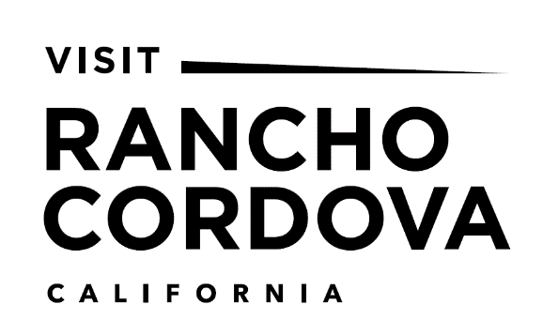

Rancho Cordova Travel and Tourism Corporation
Board of Directors Meeting
Friday, September 18, 2020 9:45 AM – 11:30 PM
Rancho Cordova City Hall
American River Room South
2729 Prospect Park Drive
Rancho Cordova, CA 95670

RCTT Values: Kaizen Respect Integrity Alignment Innovation

Agenda:
- Call to Order – Terry Park, Chair
  - Establish quorum
  - Comments by the Chair
- Project Presentation
- Public Comment – Matters Not on the Agenda
- Matters Requiring Action or Notice
  - Approval of July Meeting Minutes
- Executive Director’s Update – Marc Sapoznik
- Committee Reports
- Finance Committee
- Executive Committee
- Nominating Committee
Action Item: Sarah Alvarado Nomination
- General Discussion Items
- Chairperson’s Update
- Director Updates – Open Forum
- Property Updates
- New Business/Future Agenda Items
(Items for future consideration, may not be discussed until agendized)
XII. Adjourn
All materials relating to an agenda item for an open session of a regular meeting of the Rancho Cordova Travel and Tourism Corporation (RCTTC) board of directors which are provided to a majority or all of the members of the Committee by Committee members, staff or the public within 72 hours of but prior to the meeting will be available for public inspection, on and after at the time of such distribution, in the office of the Rancho Cordova Travel and Tourism Corporation, 2729 Prospect Park Drive, Suite 117, Rancho Cordova, California, 95670, during normal business hours, except holidays.
Public Comment: In this time period, anyone may address the Rancho Cordova Travel and Tourism Corporation Board regarding any subject over which they have jurisdiction, but which is not on today’s posted agenda. In order to provide all interested parties an opportunity to speak, time limitations shall be limited to three (3) minutes unless the Chairperson specifically authorizes more time. As required by Government Code, no action or discussion will be undertaken on any item raised during this comment period. Public comment on items listed on the agenda is taken when those items are addressed.
Access: In compliance with the Americans with Disabilities Act, if any person needs a disability-related modification or accommodation, including auxiliary aids or services, to participate in this meeting, please contact the Rancho Cordova Travel and Tourism Corporation Office at (916) 290-5166 at least 72 hours prior to the meeting.

