lo |  | Pastor Chris Brown  June 12-13, 2021  Message #7/ Philippians
 |  | northcoastchurch.com/sermons
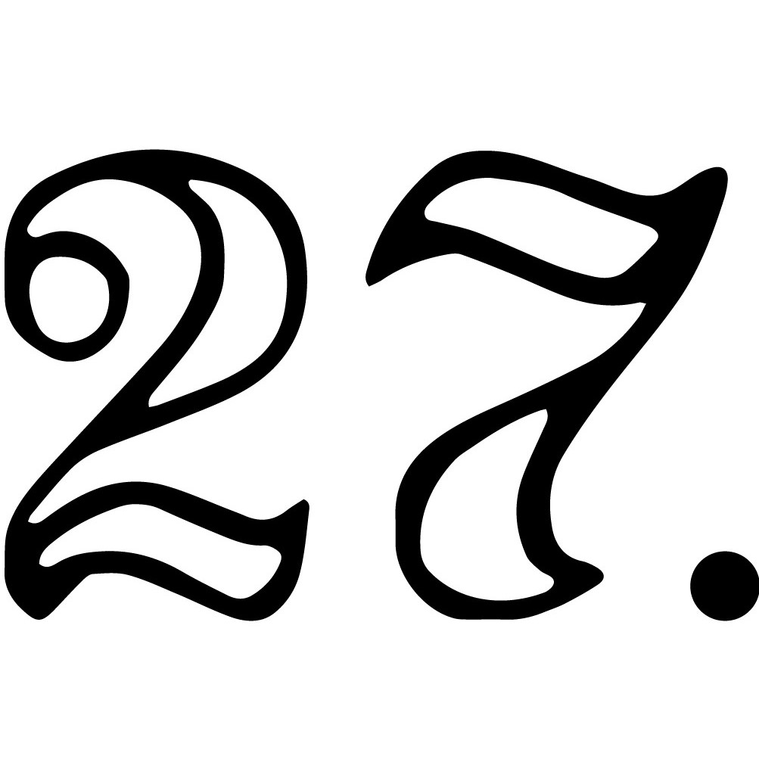
Philippians
Getting Rid Of Our Stinkin’ Thinkin’

This letter is personal:
Acts 16

It is a ______________ letter with some _________________.

The big idea of a little book:

In the book of Philippians:

Joy is mentioned _____________.

Our mindset is mentioned _____________.

Sin is mentioned ____________.

The main focus is all about ___________ and how
He should change ________________ about us.

I’m a Christian... now what?

We need to realize our salvation is _________, _____________
and ___________.

If we just focus on our _________ ______ and getting ___________,
then we will completely miss out on our ____________.

Happiness comes from focusing on _______________;
Joy comes from focusing on ____________.

Pastor Chris Brown
June 12-13, 2021
Message #7/ Philippians
northcoastchurch.com/sermons
Philippians
Getting Rid Of Our Stinkin’ Thinkin’

This letter is personal:
Acts 16

It is a THANK YOU letter with some GODLY ADVICE.

The big idea of a little book:

In the book of Philippians:

Joy is mentioned 16 TIMES.

Our mindset is mentioned 18 TIMES.

Sin is mentioned 0 TIMES.

The main focus is all about CHRIST and how
He should change EVERYTHING about us.

I’m a Christian... now what?

We need to realize our salvation is PAST, PRESENT
and FUTURE.

If we just focus on our FORGIVENESS and getting HEAVEN,
then we will completely miss out on our PRESENT.

Happiness comes from focusing on HAPPENINGS;
Joy comes from focusing on CHRIST.

Food for Thought for the week of June 13, 2021
(Readings and questions for the further study of the Book of Philippians)
_________________________________________________________________________________________________
This week’s questions walk through the Book of Philippians. Chris will also be unpacking each day’s focus on the Daily Dose, so you can follow along with him as you answer the questions. Daily Dose: Visit northcoastchurch.com/dose for details to subscribe to this free video devotional.

Monday – Chapter 1: Paul lived with the constant possibility of execution. How did that impact what he viewed as important in life and his future? What challenges you most about his view?

Tuesday – Chapter 2: Paul talked about humbly living for others. What did Paul tell us as to why we should have this “live for others” mindset? How well do you think you’re doing living for others?

Wednesday – Chapter 3: Paul revealed what his confidence was in and the reality that he still had room to grow. What stands out to you about the goal Paul had for his own spiritual journey?

Thursday – Chapter 4:1-9: What do you learn about where our focus ought to be so we can experience the joy, peace and contentment Jesus has for us?

Friday – Chapter 4:10-23: Paul stated that he had learned the secret to being content whatever his circumstances. What is that secret? How can you apply that secret to your life today?

__________________________________________________________________________________________________
Part 1 of our Summer Series: Truth and Tolerance in a Whatever Culture
(Available at multiple campuses!) This Friday, June 18, 7-9pm
“It’s true for you, but not for me.” That’s relativism in a nutshell. Alan Shlemon will explain how relativism can creep into morality and religious belief, and he will provide an accurate definition for tolerance as it should be. Alan is an author and speaker with an incredible ability for helping Christians be confident and gracious in their faith. To register for this event or other summer classes, visit northcoastchurch.com.

