lo |  | Pastor Chris Brown  June 19-20, 2021  Message #8 / Colossians
 |  | northcoastchurch.com/sermons
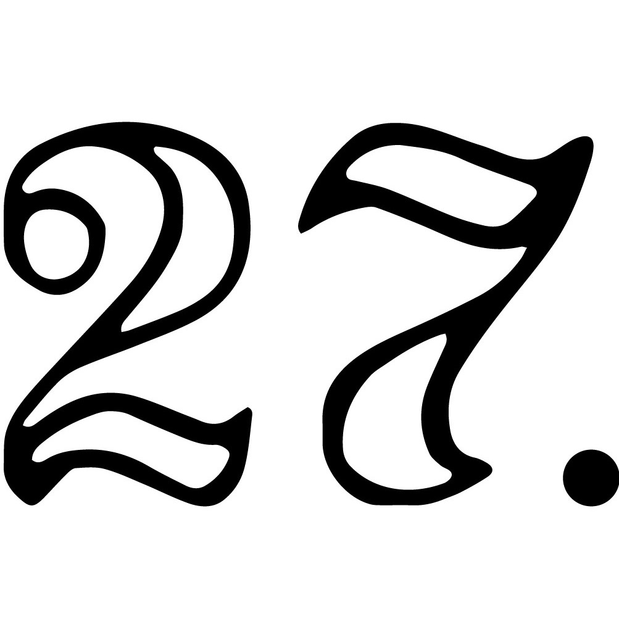
Colossians
How Does Christianity Work?

The people and places behind the letter:
Colossians

The questions that are answered:
Galatians 1:6-9, 3:1-5, 5:7-12, 6:12-13

What did Jesus do?
Colossians 1:9-14

______________, ________________, ______________,
______________, ________________

Who is Jesus?
Colossians 1:15-23

__________, ______________, ________________,
___________, ______________, __________

What does Jesus do today?
Colossians 1:24-29, 2:6-10, 3:1-2

______________, _______________, _______________

What are we supposed to do?
Colossians 3:1-17

_______________, _____________

Pastor Chris Brown
June 19-20, 2021
Message #8 / Colossians
northcoastchurch.com/sermons
Colossians
How Does Christianity Work?

The people and places behind the letter:
Colossians

The questions that are answered:
Galatians 1:6-9, 3:1-5, 5:7-12, 6:12-13

What did Jesus do?
Colossians 1:9-14

FORGAVE, REDEEMED, ADOPTED,
RESCUED, QUALIFIED

Who is Jesus?
Colossians 1:15-23

ICON, CREATOR, SUSTAINER,
HEAD, SUPREME, GOD

What does Jesus do today?
Colossians 1:24-29, 2:6-10, 3:1-2

INHABITS, EMPOWERS, GIVES LIFE

What are we supposed to do?
Colossians 3:1-17

TAKE OFF, PUT ON

Food for Thought for the week of June 20, 2021
(Readings and questions for the further study of the Book of Colossians)
_________________________________________________________________________________________________
Monday – Read 1:1-14: In vs. 9-12, Paul once again includes a prayer for the readers of his letter. What is the outcome Paul desires to see in their lives? (Note the words “so that” in v. 10, which mean what follows is the reason for his prayer.) Which part of that prayer would you most like to be true of your life?

Tuesday – Read 1:15-29 & 2:13-15: Take a few minutes to marvel at who Christ is (vs. 1:15-20) and what He has done for you (vs. 1:21-23 & 2:13-15). Express your appreciation for what He has done for you in a prayer of thanksgiving.

Wednesday – Read Chapter 2: Paul warns the Colossians about falling prey to “hollow and deceptive philosophy.” What stands out to you about the freedom we have in Christ in vs. 16-23 because of all He has done for us?

Thursday – Read 3:1-17: In this passage, Paul tells the Colossians “how to dress.” Which of the things he mentions we shouldn’t wear is hardest for you to take off? Which of the things he mentions we should be wearing is most needed for you to put on?

Friday – Read 3:18-4:18: How could you put into practice the parts of Paul’s teaching about family life and work that fit your life situation? Which part of Paul’s prayer in 4:2-4 would you like others to pray for you? What are two to three ways you can be wise toward “outsiders” as Paul suggests in 4:4-6?

__________________________________________________________________________________________________
Summer Service Projects
Looking for a great summer project? Please check out the options to serve meals to those in need at Bread of Life on Wednesday nights and Operation Hope on Thursday nights. Go to northcoastcommunityservice.org/ for more information or to register.

Summer Classes
We have a great collection of both in-person and virtual classes on a variety of topics being offered throughout the summer! Check out northcoastchurch.com/north-coast-classes/ to see what’s happening and register today!

