lo |  | Pastor Trent Jenkins  July 10-11, 2021  Message #11 / 1 Timothy
 |  | northcoastchurch.com/sermons
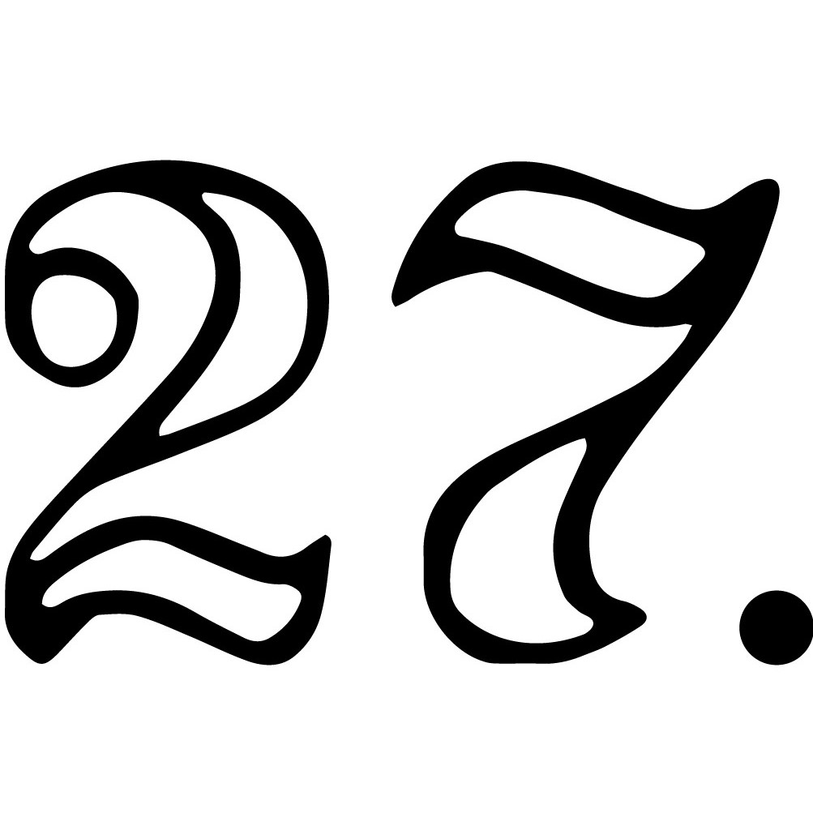
1 Timothy
A Big Assignment With A Simple Solution

The Setting Behind The Letter:
Acts 16:1-4, Acts 19, 1 Timothy 1:5, 3:15

The Big Problem: ______________________________________.
1 Timothy 1:3-7

The Big Assignment: _________________________________.
1 Timothy 3:15

The Solution: _______________________________________________________________________.
1 Timothy 4:11

Understanding the Law of the ________

What Is My Part?

Am I a ___________ or a _____________?

Am I ___________?

The Simple Solution:

Do my _________ and ______________ God for greater things.

God wants my _______________ more than my _________________.
1 Timothy 4:12

Pastor Trent Jenkins
July 10-11, 2021
Message #11 / 1 Timothy
northcoastchurch.com/sermons
1 Timothy
A Big Assignment With A Simple Solution

The Setting Behind The Letter:
Acts 16:1-4, Acts 19, 1 Timothy 1:5, 3:15

The Big Problem: THE CHURCH IS BEING LED ASTRAY.
1 Timothy 1:3-7

The Big Assignment: GET GOD’S HOUSE IN ORDER.
1 Timothy 3:15

The Solution: TIMOTHY NEEDS TO COMMAND AND TEACH THE RIGHT THINGS.
1 Timothy 4:11

Understanding the Law of the LID

What Is My Part?

Am I a LEADER or a FOLLOWER?

Am I READY?

The Simple Solution:

Do my BEST and BELIEVE God for greater things.

God wants my CHARACTER more than my COMPETENCY.
1 Timothy 4:12

Food for Thought for the week of July 11, 2021
(Readings and questions for the further study of the Book of 1 Timothy)
_________________________________________________________________________________________________
The Food for Thought this week is designed to be used along with the Daily Dose. Visit northcoastchurch.com/dose for details to subscribe to this free video devotional.

Day 1 – Read Chapter 1: As Paul begins his letter to Timothy, he leads from the perspective that he is a sinner who received mercy he didn’t deserve purely for the sake of displaying Christ’s patience to others. How challenging is it for you to remember you didn’t deserve Christ’s mercy? Write out a list of things Jesus has forgiven you for. What strikes you about Christ’s mercy as you reflect on your list?

Day 2 – Read Chapter 2: The very first instruction Paul gives Timothy for getting God’s house in order in Ephesus is to “first of all, pray.” Prayer reminds us of where our focus, purpose and trust should be—in God. How often do you remember to pray before anything else? What other things are you tempted to put before prayer?

Day 3 – Read Chapters 3-4: Paul reminds Timothy about the importance of training in godliness. He uses phrases like “devote yourself,” “be diligent,” “give yourself wholly” and “watch closely,” which imply taking a proactive role in this pursuit of godliness. What could you do to pay closer attention to godliness in your life? What does it look like to prioritize knowing God as you set out to be an example to others?

Day 4 – Read Chapters 5-6: Paul closes with a call to contentment and taking hold of true life, as opposed to what the world offers. This involves choosing to be grateful. How would you describe your current heart posture when it comes to gratefulness and contentment? Are there any areas where you can be more grateful for what you have? In what ways do you see God working within what you have right now?

__________________________________________________________________________________________________
Introductory Life Groups
Introductory Life Groups start this Thursday! If you have never been in a Life Group, this is a great way to get connected. Go to northcoastchurch.com/intro to register!

Summer Classes
We have a great selection of both in-person and virtual classes on a variety of topics! Check out northcoastchurch.com/classes to see what’s happening and register today!

