lo |  | Pastor Chris Brown  September 11-12, 2021  Message #19 / 1 John
 |  | northcoastchurch.com/sermons
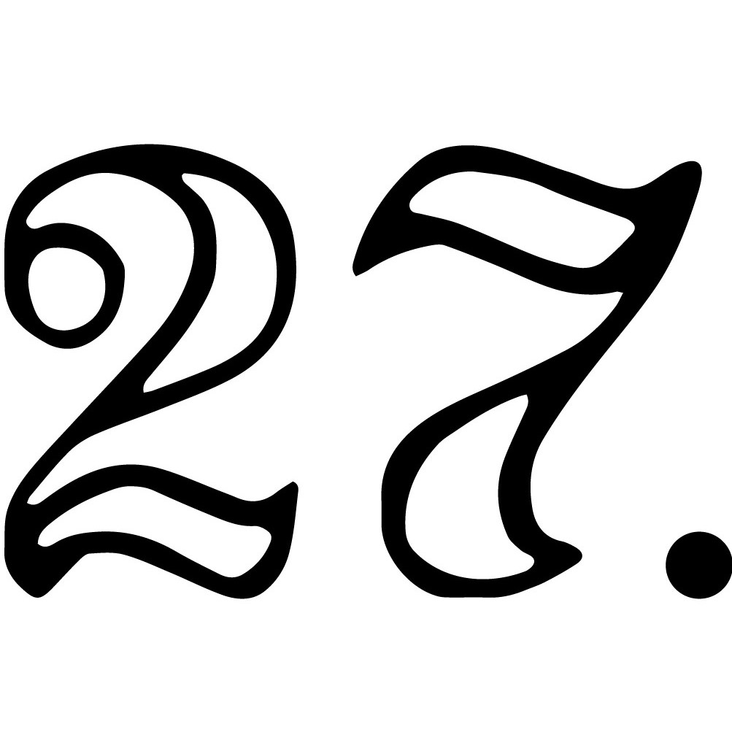
1 John
How To Walk With God

The person and purpose behind the book:
1 John 5:13

John simply wants us to know FOR SURE that
we have ETERNAL LIFE.
1 John 5:13

This is PERSONAL and RELATIONAL for John and for us.
1 John 1:1-4

The two big ideas:
1 John 1:5-3:10, 3:11-5:17

God is LIGHT.

If we walk in OBEDIENCE, then we walk in the LIGHT. If we
don’t walk in OBEDIENCE, then we don’t walk in the LIGHT.
Obedience is loving ONE ANOTHER as Jesus loved us.

God is LOVE.

If we LOVE EACH OTHER, then we walk with GOD. If we
don’t LOVE EACH OTHER, then we don’t walk with GOD.

WARNING! We are not the source of either LIGHT or LOVE!
John 15:1-17, Galatians 2:20

There is a HUGE difference between trying to PRODUCE light and love,
versus WALKING IN light and love.

The best way to connect with us is the Connection Card in the bulletin. For the Digital Bulletin, visit myncc.info.
Pastor Chris Brown
September 11-12, 2021
Message #19 / 1 John
northcoastchurch.com/sermons
1 John
How To Walk With God

The person and purpose behind the book:
1 John 5:13

John simply wants us to know _____________ that
we have ___________________.
1 John 5:13

This is _____________ and _______________ for John and for us.
1 John 1:1-4

The two big ideas:
1 John 1:5-3:10, 3:11-5:17

God is __________.

If we walk in _______________, then we walk in the __________. If we don’t walk in ______________, then we don’t walk in the __________.
Obedience is loving ________________ as Jesus loved us.

God is _________.

If we ____________________, then we walk with ________. If we don’t ____________________, then we don’t walk with ________.

WARNING! We are not the source of either ___________ or _________!
John 15:1-17, Galatians 2:20

There is a HUGE difference between trying to ____________ light and love,
versus _______________ light and love.

The best way to connect with us is the Connection Card in the bulletin. For the Digital Bulletin, visit myncc.info.

Food for Thought for the week of September 12, 2021
(Readings and questions for the further study of the Book of 1 John)
_________________________________________________________________________________________________
Day 1 – Read Chapter 1
Verses 5-10 speak about the importance of recognizing and confessing our sins. Why do you think we cannot just be free of sin?

Day 2 – Read Chapter 2
The early verses in this chapter reference Jesus speaking to the Father in our defense. Also in these verses, Jesus is referred to as the atoning sacrifice for our sins. What does this mean to you?

Day 3 – Read Chapter 3
Chris captured the importance of loving one another in his message this weekend by saying, “If we love each other, then we walk with God. If we don’t love each other, then we don’t walk with God.” What guidance does John give about some specific ways we are to love one another?

Day 4 – Read Chapter 4
Since God is love, what does John teach us about how we can use God’s example and inspiration to show love to others? Can’t we just choose to love others on our own? Why or why not?

Day 5 – Read Chapter 5
John speaks of the importance of overcoming the world; in other words, overcoming the battle over the lure and temptations of the world. How can we tap into God’s power to overcome the world?

Life Group Sign-ups are open now through September 19! Visit northcoastchurch.com/groups to find a group for you!

