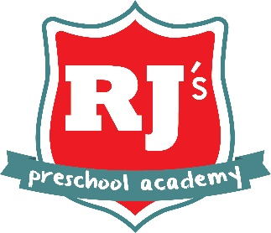

Weekly Rate Sheet
Effective 9/13/2021

Infants and Toddlers
(under age 2)

Hours of Operation:
M-F 7:30 am to 5:00 pm

Checks can be made payable to: RJKCCC

$120 annual registration fee

Monday – Friday
$346 per week

Monday, Wednesday, Friday
$208 per week

Tuesday, Thursday
$139 per week

*Pricing includes breakfast, lunch, and an afternoon snack

* We offer Kirkland Formula and some baby foods

*This is an equal opportunity provider

